http://beru.univ-brest.fr/%7Esinghoff/cheddar/gif/blueline.gif

**Cheddar Release 3.x user's guide**

***Lab-STICC technical report  
  
Updated in July, 2014  
  
Christian Fotsing, Frank Singhoff***

Cheddar is a free real time scheduling framework. Cheddar is designed for checking task temporal constraints of a real time application/system. It can also help you for quick prototyping of real time schedulers. Finally, it can be used for educational purpose. Cheddar is a free software, and you are welcome to redistribute it under certain conditions; See the GNU General Public License for details. The Cheddar project was started in 2002 by the LISyC Team, University of Western Britanny. Since 2008, Ellidiss technologies also contributes to the development of Cheddar and provides industrial support.

**WARNING : this user's guide supposes that you have a minimum background on real time applications/systems and real time scheduling. If it's not your case,** [**take a look on this link which includes some very basic articles or book references**](http://beru.univ-brest.fr/%7Esinghoff/cheddar/publications/basic-rts.html)**.** This link also provides a description of the analytical methods implemented into Cheddar and gives some publications that show how to use Cheddar.

To completed this user guide, you also have in [this technical report](http://beru.univ-brest.fr/%7Esinghoff/cheddar/cheddar_adl/cheddar_adl.pdf) , a precise description of all entities used in Cheddar.

http://beru.univ-brest.fr/%7Esinghoff/cheddar/gif/blueline.gif

* [**I. Basic scheduling simulation features and feasibility tests**](http://beru.univ-brest.fr/%7Esinghoff/cheddar/ug/ug_v3/cheddar-r3.html#Ref1) 
  + [**I.1 First step : a simple scheduling simulation**](http://beru.univ-brest.fr/%7Esinghoff/cheddar/ug/ug_v3/cheddar-r3.html#Ref1.1)
  + [**I.2 Other available schedulers and task arrival patterns**](http://beru.univ-brest.fr/%7Esinghoff/cheddar/ug/ug_v3/cheddar-r3.html#Ref1.2)
  + [**I.3 Scheduling options**](http://beru.univ-brest.fr/%7Esinghoff/cheddar/ug/ug_v3/cheddar-r3.html#Ref1.3)
* [**II. About Cheddar project files (XML and AADL files)**](http://beru.univ-brest.fr/%7Esinghoff/cheddar/ug/ug_v3/cheddar-r3.html#Ref2)
* [**III. Summary of the Cheddar command line**](http://beru.univ-brest.fr/%7Esinghoff/cheddar/ug/ug_v3/cheddar-r3.html#Ref3)
* [**IV. Scheduling with task dependencies**](http://beru.univ-brest.fr/%7Esinghoff/cheddar/ug/ug_v3/cheddar-r3.html#Ref4) 
  + [**IV.1 Shared resources analysis tools**](http://beru.univ-brest.fr/%7Esinghoff/cheddar/ug/ug_v3/cheddar-r3.html#Ref4.1)
  + [**IV.2 Task precedencies**](http://beru.univ-brest.fr/%7Esinghoff/cheddar/ug/ug_v3/cheddar-r3.html#Ref4.2) 
    - [**IV.2.1 Editing Task precedencies**](http://beru.univ-brest.fr/%7Esinghoff/cheddar/ug/ug_v3/cheddar-r3.html#Ref4.2.1)
    - [**IV.2.2 How to transform a dependent task set into an undependent task set : the Chetto/Blazewicz modification rules**](http://beru.univ-brest.fr/%7Esinghoff/cheddar/ug/ug_v3/cheddar-r3.html#Ref4.2.2)
    - [**IV.2.3 Computing end to end response time : the Holistic approach**](http://beru.univ-brest.fr/%7Esinghoff/cheddar/ug/ug_v3/cheddar-r3.html#Ref4.2.3)
  + [**IV.3 Buffer analysis tools**](http://beru.univ-brest.fr/%7Esinghoff/cheddar/ug/ug_v3/cheddar-r3.html#Ref4.3)
  + [**IV.4 Message scheduling services**](http://beru.univ-brest.fr/%7Esinghoff/cheddar/ug/ug_v3/cheddar-r3.html#Ref4.4)
* [**V. Multiprocessor scheduling services**](http://beru.univ-brest.fr/%7Esinghoff/cheddar/ug/ug_v3/cheddar-r3.html#Ref5)
* [**VI. User-defined simulation code : how to run simulations of specific systems**](http://beru.univ-brest.fr/%7Esinghoff/cheddar/ug/ug_v3/cheddar-r3.html#Ref6) 
  + [**VI.1 Examples of user-defined schedulers**](http://beru.univ-brest.fr/%7Esinghoff/cheddar/ug/ug_v3/cheddar-r3.html#Ref6.1) 
    - [**VI.1.1 Low-level statements versus High-level statements**](http://beru.univ-brest.fr/%7Esinghoff/cheddar/ug/ug_v3/cheddar-r3.html#Ref6.1.1)
    - [**VI.1.2 User-defined scheduler built with User's defined Task Parameters**](http://beru.univ-brest.fr/%7Esinghoff/cheddar/ug/ug_v3/cheddar-r3.html#Ref6.1.2)
  + [**VI.2 Scheduling with user-defined task arrival patterns**](http://beru.univ-brest.fr/%7Esinghoff/cheddar/ug/ug_v3/cheddar-r3.html#Ref6.2)
  + [**VI.3 Running a simulation with a user-defined scheduler**](http://beru.univ-brest.fr/%7Esinghoff/cheddar/ug/ug_v3/cheddar-r3.html#Ref6.3)
  + [**VI.4 Looking for user-defined properties during a scheduling simulation**](http://beru.univ-brest.fr/%7Esinghoff/cheddar/ug/ug_v3/cheddar-r3.html#Ref6.4)
  + [**VI.5 List of predefined variables and available statements for user-defined code**](http://beru.univ-brest.fr/%7Esinghoff/cheddar/ug/ug_v3/cheddar-r3.html#Ref6.5)
* [**VII. Summary of Cheddar's editor menus and sub-menus**](http://beru.univ-brest.fr/%7Esinghoff/cheddar/ug/ug_v3/cheddar-r3.html#Ref7)

http://beru.univ-brest.fr/%7Esinghoff/cheddar/gif/blueline.gif

**I. Basic scheduling simulation features and feasibility tests for independent tasks**

In this chapter, you find a description of the most important scheduling and feasibility services provided by Cheddar in the case of independent tasks.

**I.1 First step : a simple scheduling simulation**

This section shows you how to call the simpliest features of Cheddar.

Cheddar provides tools to check temporal constraints of real time tasks. These tools are based on classical results from real time scheduling theory. Before calling such tools, you have to define a system which is mainly composed of several processors and tasks.

To define a processor, you should first define one or multiple cores. For that choose the "Edit/Entities/Hardware/Core" submenu. The window below is then displayed :

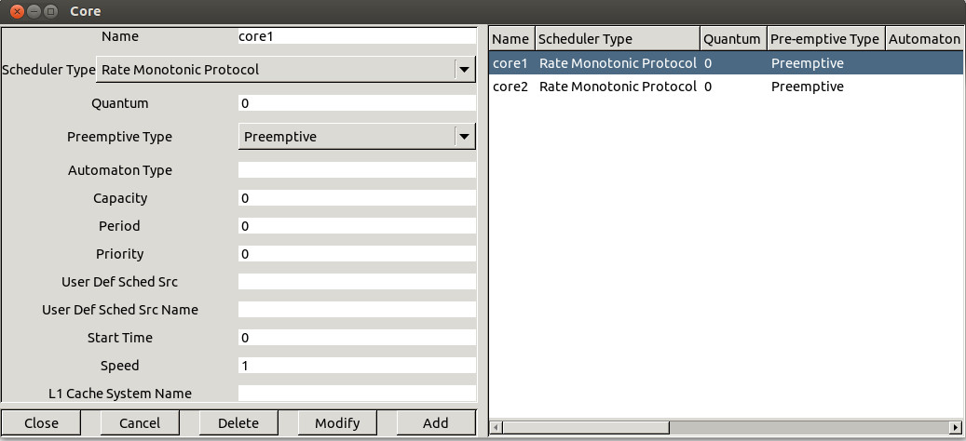

*Figure 1.1 Adding a core*

A core is defined by the following fields (see Figure 1.1) :

1. The **name** of the core. A core name can be any combination of literal characters including underscore. Space is forbidden. Each core must have a unique name.
2. The **scheduler** hosted by the core. Basically, you can choose from a various set of schedulers such as (to get a detailed description on these schedulers, see your preferred real time books of the publications provided with this program) :
   * "Earliest Deadline First (or EDF)". Tasks can be periodic or not and are scheduled according to their deadline.
   * "Least Laxity First (or LLF)". Tasks can be periodic or not and are scheduled according to their laxity.
   * "Rate Monotonic (or RM, or RMA, or RMS)". Tasks have to be periodic, and deadline must be equal to period. Tasks are scheduled according to their period. You have to be aware that the value of the priority field of the tasks is ignored here.
   * "Deadline Monotonic (or DM)". Tasks have to be periodic and are scheduled according to their deadline. You have to be aware that the value of the priority field of the tasks is ignored here.
   * "POSIX 1003.1b scheduler ". Tasks can be periodic or not. Tasks are scheduled according to the priority and the policy of the tasks. (Rate Monotonic and Deadline Monotonic use the same scheduler engine except that priorities are automatically computed from task period or deadline). POSIX 1003.1b scheduler supports SCHED_RR, SCHED_FIFO and SCHED_OTHERS queueing policies. SCHED_OTHERS is a time sharing policy. SCHED_RR and SCHED_FIFO tasks must have priorities ranging between 255 and 1. Priority level 0 is reserved for SCHED_OTHERS tasks. The highiest priority level is 255.
   * "Time sharing based on waiting time (which is a Linux-like scheduler)" and "Time sharing based on cpu usage". These two schedulers provide a way to share the processor as on a time sharing operatong system. With the first scheduler, the more a ready task waits for the processor and the more its priority increases. With the second scheduler, the more a ready task uses the processor and the more its priority decreases.
   * Round robin (with quantum). The processor is regulary shared between all the tasks. A quantum (which is a bound on the time a task keeps the processor) can be given.
   * "Maximum Urgency First based on laxity" and "Maximum Urgency First based on deadline". Such schedulers are based on an hybrid priority assignment : a task priority is made of a fixed part and a dynamic part (see ).
   * "D-Over/Stable EDF". This scheduler is an EDF like but which is work fine when the processor is over-loaded. When the processor is over-loaded, D-Over is always able to predict which tasks will miss its deadline (in contrary to EDF).
   * User-defined schedulers ("Pipeline user-defined scheduler", "Automata user-defined scheduler" or "Compiled user-defined scheduler"). These schedulers allow users to define their own scheduler into Cheddar (see section [**VI**](http://beru.univ-brest.fr/%7Esinghoff/cheddar/ug/ug_v3/cheddar-r3.html#Ref6) for details).
   * ...
3. If the scheduler is **preemptive or not**. By default, the scheduler is set to be preemptive.
4. The **quantum** value associated with the scheduler. This information is useful if a scheduler has to manage several tasks with the same dynamic or static priority : in this case, the simulator has to choose how to share the processor between these tasks. The quantum is a bound on the delay a task can hold the processor (if the quantum is equal to zero, there is no bound on the processor holding time). At the time we're speaking, the quantum value can be used with the POSIX 1003.1b scheduler (only with SCHED_RR tasks) and the round robin scheduler. With POSIX 1003.1b, two SCHED_RR tasks with the same priority level should share the processor with a POSIX round-robin policy. In this case, the quantum value is the time slot of this round-robin scheduler. Finally, the quantum value could also be used for user-defined scheduler (see part [**VI**](http://beru.univ-brest.fr/%7Esinghoff/cheddar/ug/ug_v3/cheddar-r3.html#Ref6) for details).
5. **Automaton type** ....
6. **Capacity** ....
7. **Period** ....
8. **Priority** ....
9. **User Defined Scheduler Source** ....
10. The **file name :** it's the name of a filewhich contains the source code of a user-defined scheduler (see section [**VI**](http://beru.univ-brest.fr/%7Esinghoff/cheddar/ug/ug_v3/cheddar-r3.html#Ref6) for details).
11. **Start time** ....
12. **Speed** ....
13. **L1 Cache system name** ....

**Warning** : with Cheddar, to add a core (or any object), you have to push the Add button before pushing the Close button. That allows you to define several objects quickly whithout closing the window (you should then push Add for each defined object).

Then you can define a processor. For that choose the "Edit/Entities/Hardware/Processor" submenu. The window below is then displayed :

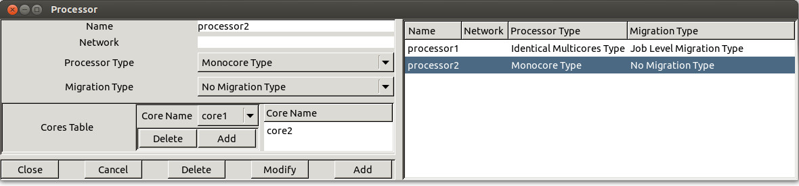

*Figure 1.2 Adding a processor*

A processor is defined by the following fields (see Figure 1.2) :

1. The **name** of the processor. A processor name can be any combination of literal characters including underscore. Space is forbidden. Each processor must have a unique name.
2. At the time we're speaking, the network field is not used (planned to be used in order to simulate message scheduling).
3. **Processor type** ....
   * **Monocore type** ....
   * **Identical multicores type** ....
   * **Uniform multicores type** ....
   * **Unrelated multicores type** ....
4. **Migration type** ....
   * **No migration type** ....
   * **Job level migration type** ....
   * **Time unit migration type** ....
5. **Cores table** which contain the list of cores initially defined. The user should select one core in the monocore processor case, and almost one core in other case.

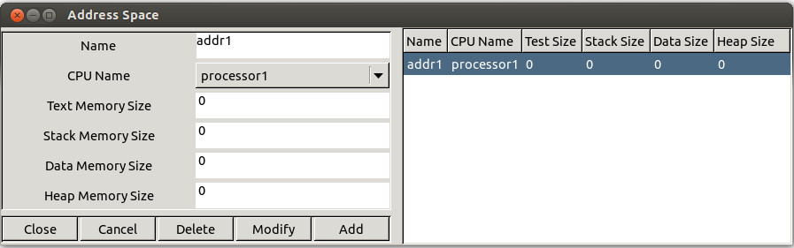

*Figure 1.3 Adding an address space*

The next step in order to run a simulation, is to define an address space. Choose the "Edit/Entities/Software/Address space" submenu. An address space models a piece of memory which contain tasks, buffers or shared resources. The Figure 1.3 shows the widget used to define such a feature. At the time we are speaking, the information you have to provide is :

* **A name.** An address space name can be any combination of literal characters including underscore. Space is forbidden. Each address space name has to be unique.
* **A processor name.** This is the processor which hosts the address space.
* Some fields related to the size of the address space memory : the **text memory size**, the **heap memory size**, the **stack memory size** and the **data memory size**. The fields related to memory size will be used in the next Cheddar's release in order to perform a global memory analysis.

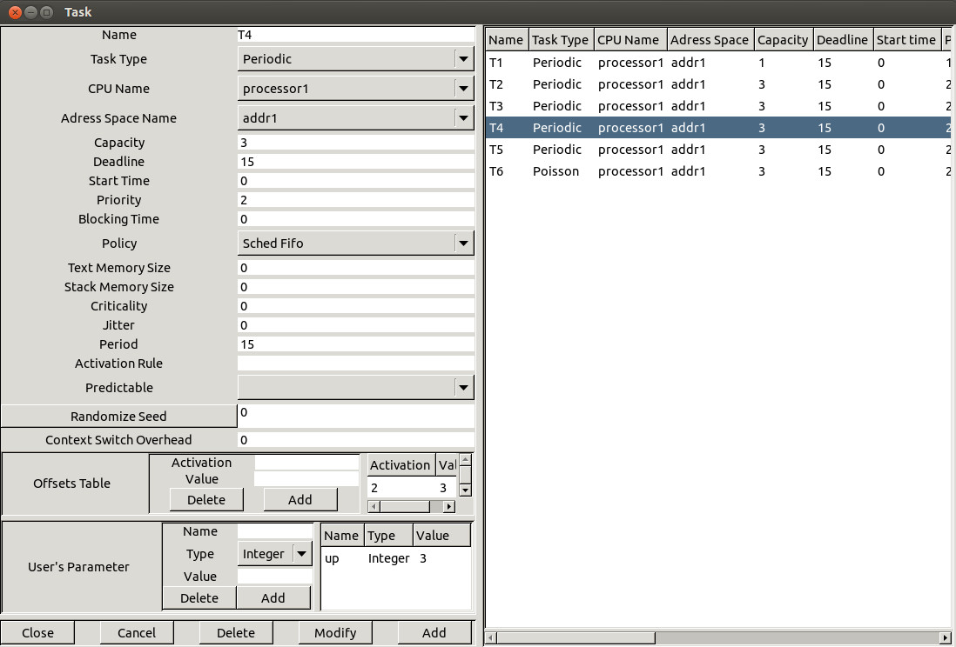

*Figure 1.4 Adding a task*

Let see now, how to define a task, the last feature required to perform the most simpliest performance analysis. Choose the "Edit/Entities/Software/Task" submenu. The window of Figure 1.4 is then displayed. This window is composed of 3 sub-parts : the "main part", the "offset part" and the "user's defined parameters part". The main part contains the following informations :

1. At least, a task is defined by a **name** (the task name should be unique), a **capacity** (bound on its execution time) and a place to run it (a **processor name** and an **address space name**). The other parameters are optional but can be required for a particular scheduler
2. A **type of task** . It describes the way the task is activated. An aperiodic task is only activated once. A periodic task is activated many times and the delay between two activations is a fixed one. A poisson process task is activated many times and the delay between two activations is a random delay : the random law used to generated these delays is an exponential one (poisson process). a sporadic task is a task which is activated many times with a minimal delay between two succesive activations. If the task type is "user-defined", the task activation law is defined by the user (see section [**VI.2**](http://beru.univ-brest.fr/%7Esinghoff/cheddar/ug/ug_v3/cheddar-r3.html#Ref6.2) of this user's guide).
3. The **period**. It is the time between two task activations. The period is a constant delay for a periodic task. It's an average delay for a poisson process task. If you have selected a processor that owns a Rate Monotonic or a Deadline Monotonic scheduler, you have to give a period for each of its tasks.
4. A **start time**. It is the time when the task arrives in the system (its first activation time).
5. A **deadline**. The task must end its activation before its deadline. A deadline is a relative information : to get the absolute date at which a task must end an activation, you should add the time when the task was awoken/activated to the task deadline. **Warning** : the deadline must be equal to the period if you define a Rate Monotonic scheduler.
6. A **priority** and a **policy**. These parameters are dedicated to the POSIX 1003.1b/Highest Priority First scheduler. Priority is the fixed priority of a task. Policy can be SCHED RR, SCHED FIFO or SCHED OTHERS and describes how the scheduler chooses a task when several tasks have the same priority level. **Warning** : the **priority** and the **policy** are ignored by a Rate Monotonic and a Deadline Monotonic scheduler.
7. A **jitter**. The jitter is a maximum lateness on the task wake up time. This information can be used to express task precedencies and to applied method such as the Holistic task response time method.
8. A **blocking time**. It's a bound on shared resource waiting time. This delay could be set by the user but could also be computed by Cheddar if you described how shared resources are accessed.
9. An **activation rule**. The name of the rule which defines the way the task should be activated. Only used with user-defined task. (see section [**VI.2**](http://beru.univ-brest.fr/%7Esinghoff/cheddar/ug/ug_v3/cheddar-r3.html#Ref6.2) for details).
10. A **criticality level** . The field indicates how the task is critical. Currently used by the MUF scheduler or any user-defined schedulers.
11. A **seed** . If you define a poisson process task or a user-defined task, you can set here how random activation delay should be generated (in a deterministic way or not). The "Seed" button proposes you a randomly generated seed value but of course, you can give any seed value. This seed value is used only if the **Predictable** option is selected. If the **Unpredictable** option is selected, the seed is initialized at simulation time with "gettimeofday".
12. The **text memory size** and **stack memory size**. The fields related to task memory size will be used in the next Cheddar's release in order to perform memory requirement analysis.

The second and the third parts store task information which are less used by users.   
  
The **offsets** part is a table. Each entry of the table stores two informations : an activation number and a value. The offset part allows the user to change the wake up time of a task on a given activation number. For each activation number stored in the "Activations:" fields, the task wake up time will be delayed by the amount of time given in the "Values" fields.

Finally, the third part (the **"User's defined parameters"** part) contains task parameters (similar to the deadline, the period, the capacity ...) used by user-defined schedulers. With this part, a user can define new task parameters. A user-defined task parameter has a value, a name and a type. The types currently available to defined user-defined task parameters are : string, integer boolean and double.

**Warning :** when you create tasks, in most of cases, Cheddar does not check if your task parameters are erronous according to the scheduler you previously selected : these checks are done at task analysis/scheduling. Of course, you can always change task and processor parameters with "Edit menus.

When tasks and processors are defined, we can start the task analysis. Cheddar provides two kind of analysis tools :

1. **Feasibility analysis tools** : these tools compute much information without scheduling the set of tasks. Equation references used to compute this feasibility information are always provided with the results. Feasibility services are provided for tasks and buffers.
2. **Simulation analysis tools** : With these tools, scheduling has to be computed first. When the scheduling is computed (of course, this step can be long to proceed ...), the resulting scheduling is drawn in the top part of the window and information is computed and displayed in the bottom part of the window. Information retrieved here is only valid in the computed scheduling.The simpliest tools provided by Cheddar check if a set of tasks meet their temporal constraints. Simulation services are also provided for other resources (for buffers for instance).

All these tools can be called from the "Tools" Menu and from some toolbar Buttons :

* From the submenu "Tools/Scheduling/Customized scheduling simulation", the scheduling of each processor is drawn on the top of the Cheddar main window (see below). From the drawn scheduling, missed deadlines are shown and some statistics are displayed (number of preemption for instance).
* From the submenu "Tools/Scheduling/Customize scheduling feasibility", response time, base period and processor utilization level are computed and displayed on the bottom of the Cheddar main window (see Figure 1.5).

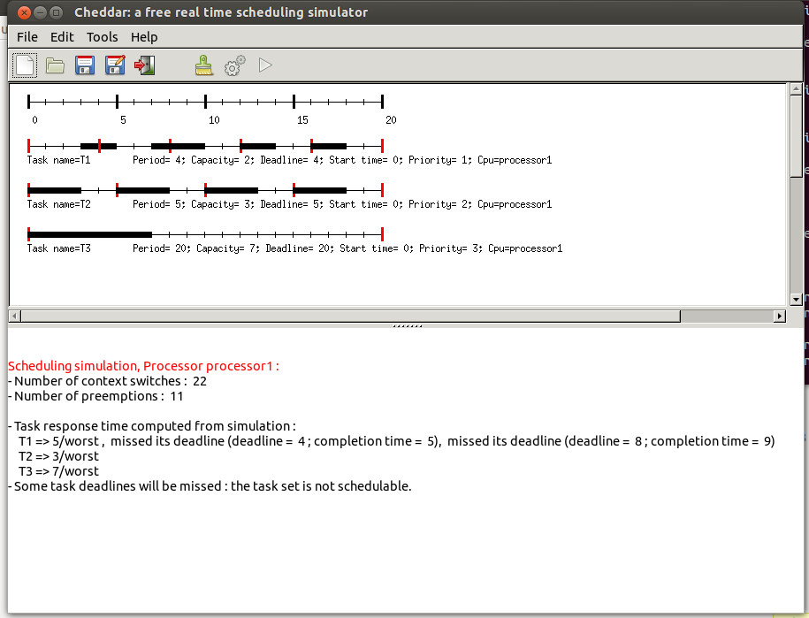

*Figure 1.5 The Cheddar's main window*

In the top part of this window, each resource, buffer, message and task is shown by a time line :

1. For a task time line :
   * Each vertical red line means that the task is activated (woken up) at this time.
   * Each black rectangle means that the task is running at this time.
2. For a resource time line :
   * Each vertical blue line means that the resource is allocated by a task at this time.
   * Each black rectangle means that the resource is used by the task which is running at this time.
3. For a message time line : each black rectangle means that the message is beeing transmitted by the network.
4. For a buffer time line :
   * Each write rectangle means that a task writes data into a buffer.
   * Each red rectangle means that a task reads data from a buffer.

The scheduling result can also be saved in XML file. This is particulary usefull if you do not want to use the Cheddar Machine-Man-Interface. For example, the computed scheduling as an event table. The event table is the data structure used by the simulator engine to perform analysis on scheduling. The event produced by the simulator are : Start_Of_Task_Capacity, End_Of_Task_Capacity, Write_To_Buffer, Read_From_Buffer, Running_Task, Task_Activation, Send_Message, Receive_Message, Allocate_Resource, Release_Resource Address_Space_Activation and Wait_For_Resource. In a XML event table file, each event is exported with the time the event occurs. For each event, some extra data related to the event can also be exported :

* Start_Of_Task_Capacity. This event is generated when a task run the fist unit of time of its capacity. The exported information is the name of the task.
* End_Of_Task_Capacity. This event is generated when a task run the last unit of time of its capacity. The exported information is the name of the task.
* Write_To_Buffer. This event is generated when a task write data into a buffer. The exported information is the name of the buffer, the name of the task and the size of the written data.
* Read_From_Buffer. This event is generated when a task read data from a buffer. The exported information is the name of the buffer, the name of the task and the size of the read data.
* Running_Task. This event is generated when a task get the processor. The exported information is the name of the running task.
* Task_Activation. This event is generated when a task is awoken. The exported information is the name of the awoken task.
* Send_Message. This event is generated when a task is sending a message. The exported information is the name of the message and the name of the task.
* Receive_Message. This event is generated when a task is receiving a message. The exported information is the name of the message and the name of the task.
* Allocate_Resource. This event is generated when a task takes a resource. The exported information is the name of the resource and the name of the task.
* Release_Resource. This event is generated when a task releases a resource. The exported information is the name of the resource and the name of the task.
* Wait_For_Resource. This event is generated when a task waits for the access to a resource. The exported information is the name of the resource and the name of the task.

You can take a look on the following event tables to have an idea of the data layout of such XML file :

* [event_table.xml](http://beru.univ-brest.fr/%7Esinghoff/cheddar/ug/ug_v3/event_table.xml) : this simple event table is produced from a set of independent task scheduled with EDF. The file [event_table_large.xml](http://beru.univ-brest.fr/%7Esinghoff/cheddar/ug/ug_v3/event_table_large.xml) is similar except the size (it is a large file produced with a 200 task set).
* [event_table_fixed_priority.xml](http://beru.univ-brest.fr/%7Esinghoff/cheddar/ug/ug_v3/event_table_fixed_priority.xml) : this event table is produced from a fixed priority scheduler.This scheduler provide an extra information for the event Running_Task. This extra information is the current priority of the running task.
* [event_table_buffer.xml](http://beru.univ-brest.fr/%7Esinghoff/cheddar/ug/ug_v3/event_table_buffer.xml) : this event table is produced from a set of tasks sharing a buffer.
* [event_table_shared_resource.xml](http://beru.univ-brest.fr/%7Esinghoff/cheddar/ug/ug_v3/event_table_shared_resource.xml) : this event table is produced from a set of tasks sharing a PCP resource.
* [event_table_message.xml](http://beru.univ-brest.fr/%7Esinghoff/cheddar/ug/ug_v3/event_table_message.xml) : this event table is produced from a set of tasks sending/receiving messages.

To get a summary of the tools provided by Cheddar, see section [**VI**](http://beru.univ-brest.fr/%7Esinghoff/cheddar/ug/ug_v3/cheddar-r3.html#Ref6) .

**I.2 Other Available schedulers and task arrival patterns**

In Cheddar, you will find several schedulers. Some of them are directly implemented into the framework ; others can be defined by the user. The list below describes the currently built-in schedulers you may find in the 1.3p15 release :

* Rate Monotonic : run the task with the smallest period first. The priority field of the tasks is ignored here. All tasks have to be periodic.
* Deadline Monotonic : run the task with the smallest static deadline first. The priority field of the tasks is ignored here. All taks have to be periodic.
* Earliest Deadline First : run the task with the smallest dynamic deadline first. Tasks can be periodic or not.
* Least Laxity First : run the task with the smallest laxity first. The laxity is computed according to the task deadline. Tasks can be periodic or not.
* POSIX 1003.1b scheduler : run the task with the highest fixed priority first. Support SCHED_RR, SCHED_FIFO and SCHED_OTHERS policies. SCHED_OTHERS is a time sharing scheduler. SCHED_RR and SCHED_FIFO are policies which enforce real time scheduling. Tasks can be periodic or not. Tasks are scheduled according to the priority and the policy of the tasks. (Rate Monotonic and Deadline Monotonic use the same scheduler engine except that priorities are automaticly computed from task period or deadline). POSIX 1003.1b scheduler supports SCHED_RR, SCHED_FIFO and SCHED_OTHERS queueing policies. SCHED_OTHERS is a time sharing policy. SCHED_RR and SCHED_FIFO tasks must have priorities range from 255 to 1. Priority level 0 is reserved to SCHED_OTHERS tasks. The highiest priority level is
* Maximum Urgency First scheduler [[STE 91]](http://beru.univ-brest.fr/%7Esinghoff/cheddar/publications/sysengr91.pdf) : run the tasks according to a mixed static and dynamic priority. The task to run is the task with the highest criticality level. If two tasks have the same crititicaly level, the scheduler then chooses the one with the smallest laxity. If two tasks have the same criticality level and the same laxity, the scheduler chooses the one with the highest fixed priority.
* D-over dynamic scheduler [[KOR 92]](http://beru.univ-brest.fr/%7Esinghoff/cheddar/publications/RT-0138.pdf) : run the tasks as EDF but with a safe policy in case of transient overload.
* Round robin scheduler : give the processor during a fixed delay to each task at a fixed order. It allows the use of a given quantum : in this case, a task stays on the processor until the quantum becomes exhausted.
* Time sharing scheduler based on task waiting time (scheduler similar to the one provided by Linux) : run the task which waits since the oldest date.
* Time sharing scheduler based on cpu usage : run the task which had consumed the least cpu time.

The current Cheddar's release also provides some User-defined/parametric schedulers stored in some .sc files (see project_examples sub-directory and [section VI](http://beru.univ-brest.fr/%7Esinghoff/cheddar/ug/ug_v3/cheddar-r3.html#Ref6)). These schedulers are :

* arinc.sc : modeling of an ARINC 653 partition and task scheduler
* schedule_according_to_criticity.parametric-cpu.sc : schedule tasks according a task criticity level
* non_preemptive_llf.sc : example of a LLF scheduler with no preemption when tasks have the same laxity value
* ts.sc : the processor is given to the task which ran the least frequently.
* fcfs.sc : first come/first served scheduling policy.
* short.sc : schedule the shortest task first (with the smallest capacity)
* dvd0.parametric-cpu.sc : Dynamic value density scheduler of the York University [[ALD 98]](http://beru.univ-brest.fr/%7Esinghoff/cheddar/publications/YCS-98-310.pdf).
* mllf.sc : Modified Least Laxity First scheduler with f=0.5 [[OVE 97]](http://beru.univ-brest.fr/%7Esinghoff/cheddar/publications/brylawski.pdf).
* muf.sc : Maximum Urgency First scheduler [[STE 91]](http://beru.univ-brest.fr/%7Esinghoff/cheddar/publications/sysengr91.pdf).

In the same way, Cheddar provides a set of built-in task arrival patterns. The built-in task arrival patterns are :

* Aperiodic tasks : this kind of task arrives in the system at a given time (the start time, see the "Update Tasks" widget), run a job and leaves the system.
* Periodic tasks : this kind of task periodically runs a job. A periodic task has a start time. The period field (see the "Update / Software/Tasks" widget) stores the fixed delay between two successive task wake-up times.
* Poisson process tasks : this kind of task periodically runs a job. A periodic task has a start time. The period field (see the "Update / Software/ Tasks" widget) stores the average delay between two successive task wake-up times. The effective delay between two wake-up times is computed with an exponential random generator.

Some examples of User-defined/Parametric task provided with this Cheddar release can be found in the files :

* sporadic.sc : tasks are woken up with a minimal inter-waking up period delay. The miminum delay is stored in the period field and the wake-up delay is randomly generated (exponential distribution).
* random_capacity.sc : task with a randomly generated capacity.
* increasing_capacity.sc : tasks with a growing capacity.
* activations.sc : various task models.

**I.3 Scheduling options.**

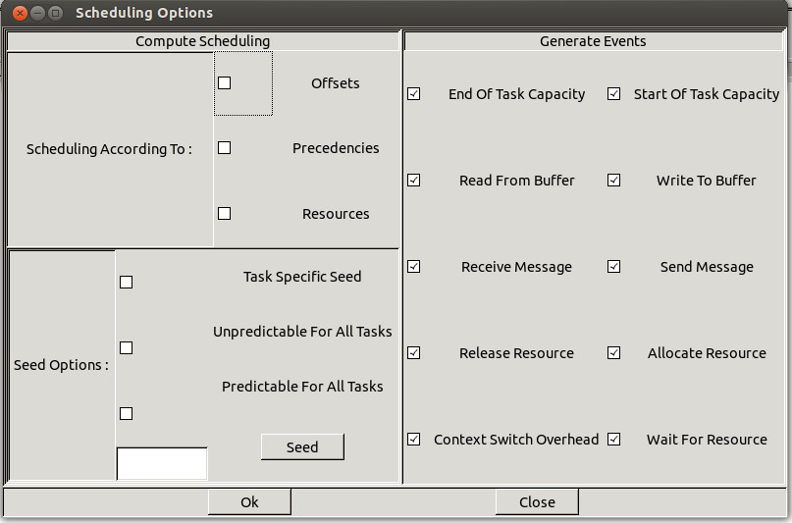

*Figure 1.6 Scheduling options windows*

The submenu "Tools/Scheduling/Options" allows you to tune the way **all next scheduling simulations** will be done (see Figure 1.6) :

* If you push the "Offsets" button, the simulation engine takes care of the task offsets given at task definition time : task activations can then be delayed if you provide offset values at task definition time.
* If you push the "Precedencies" button, task scheduling will be done so that task precedencies will be met. By default, task precedencies are ignored.
* If you push the "Resources" button, access to shared ressources will be done during simulation. By default, all shared resources are ignored.
* Cheddar allows you to activate tasks randomly . If you want to do simulations with this kind of task, the simulator engive has to compute some random values. From this window, you can tune the way random activation delays are generated. A seed value can be associated with each task but you can also use only one seed for all tasks. In the two cases, you can do "predictable" or "unpredictable" simulations. If you choose "predictable" simulation, the seed will be initialized by a given value. In the other case, the seed is initialized with "gettimeofday". . Pushing the "Predictable for all tasks" radio button leads to take the seed value of the Option window during simulation for all tasks. If the "Task specific seed" radio button is pushed instead, the seed of each task is used to generate task activation delays. You should notice that by default, 0 is given to the seed value, but of course, you can choose any value. Pushing the "Seed" button gives you a random value for the seed.
* The check button of the window on the right side allows the user to define which events will be generated into the event table at simulation time (see section V).

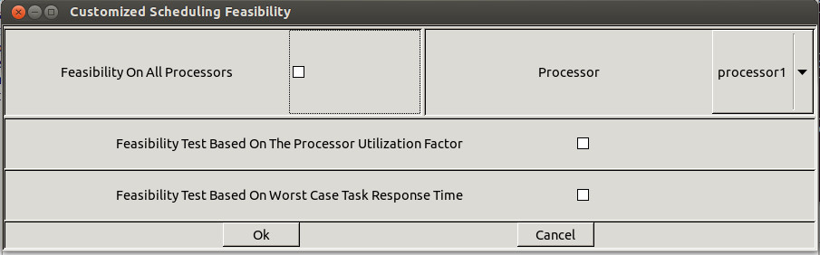

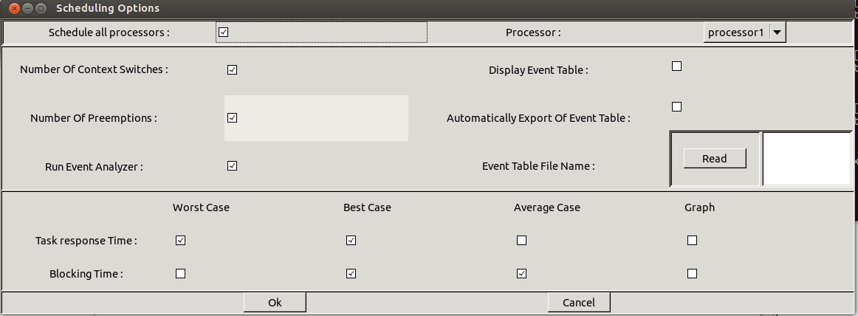

*Figure 1.7 Scheduling options windows (both feasibility and simulation)*

The submenu "Tools/Scheduling/Scheduling simulation" allows you to tune the way **the next scheduling simulation** and **the next feasibility test** will be done (see the Figure 1.7).

Options related to which information the engine has to compute when the scheduling sequence is built are :

* Pushing the "Schedule all processors" check button implies that the scheduling simulation will be computed on all defined processors. If this button stay unchecked, the user has to choose a given processor.
* Pushing the "Number of context switch" implies to compute the number of context switches from the computed scheduling sequence.
* Pushing the "Number of preemption" implies to compute the number of preemptions from the computed scheduling sequence.
* Pushing the "Task response time " implies to compute the worst/best/average task response times from the computed scheduling sequence.
* Pushing the "Blocking time" implies to compute the worst/best/average task blocking times on shared resources from the computed scheduling sequence.
* Pushing the "Run event analyzers" will imply to perform the user-defined code (see section V) on the computed scheduling sequence.
* The Display event table, Automatically export event table and Event table file name options are related to the computing scheduling sequence. These options allow you to save the computed scheduling into a file in a XML format or display it on the screen.

Options related to which information the feasibility tests will compute are :

* Pushing the "Feasibility on all processors" check button implies that the feasibility tests will be computed on all defined processors. If this button stay unchecked, the user has to choose a given processor.
* Pushing the "Feasibility test based on the processor utilization factor" will imply to compute such a test.
* Pushing the "Feasibility test based on worst case task response time" will imply to compute such a test.

http://beru.univ-brest.fr/%7Esinghoff/cheddar/gif/blueline.gif

**II. About Cheddar project files (XML and AADL files).**

Information stored during a simulation can be saved into **project files**. A project file is a XML file defined by [this DTD](http://beru.univ-brest.fr/%7Esinghoff/cheddar/ug/ug_v3/cheddar_project.dtd). By the way, you do not need a deep understanding of the layout of cheddar project files except if you want to edit project files by hand. If so, you should check if your project files are correctly structured by the tool **xml2xml** (**xml2xml** just reads, parses and displays the content of a XML Cheddar project file on the screen ).

All Cheddar XML files can be displayed with an Internet Browser if you put the following [XSLT file](http://beru.univ-brest.fr/%7Esinghoff/cheddar/ug/ug_v3/cheddar_project.xsl) and the following.[CSS file](http://beru.univ-brest.fr/%7Esinghoff/cheddar/ug/ug_v3/cheddar_project.css) in the directory hosting your XML Cheddar files. To do so, you should use a recent release of Internet Explorer (version 6.0 or later), Netscape (version 7.0 or later) or Mozilla (version 1.0 or later).

From Cheddar, there are two ways to load a project file :

* First, a project file can be loaded from the "File/Open XML project" submenu. Just click on the Open button, and give the file name of your project.
* Second, a project can be loaded from the command line. For instance, to start Cheddar and load the project file my_project.xml, just do :

my_shell$**cheddar my_project.xml**

Saving a project can be done with the same "File" menu.

Cheddar can also import AADL specification [[SAE 04]](http://beru.univ-brest.fr/%7Esinghoff/cheddar/publications/basic-rts.html). This service can be accessed through the submenu "File/AADL/Import AADL". In the same way, an XML project can be exported towards an AADL specification (see the "File/AADL/Export AADL" sub-menu). As with XML files, you can launch Cheddar with an AADL file given from the command line. To launch Cheddar and automatically read the foo.aadl AADL specification file, do :

my_shell$**cheddar -a foo.aadl**

Finally, XML or AADL files can be loaded from any directory and a project can be saved in several project files. For example, to load a project saved in two AADL files called bar1.aadl and bar2.aadl, which are stored in the directory /home/foo, you must use the following command-line :

my_shell$**cheddar -I/home/foo -a bar1.aadl bar2.aadl**

By default, Cheddar automatically loads the standards AADL files AADL_Project.aadl, AADL_Properties.aadl, Cheddar_Properties.aadl and User_Defined_Cheddar_Properties.aadl. The -I option can also be used to give the directory storing these standard AADL files. Otherwise, these files ares supposed to be in the current directory. A copy of them can be generated from the File/AADL/Export property sets used by Cheddar and File/AADL/Export standard AADL property set submenus.   
  
http://beru.univ-brest.fr/%7Esinghoff/cheddar/gif/blueline.gif

**III. Summary of the Cheddar command line.**

The basic command line of cheddar is

my_shell$**cheddar [switches] foo1 foo2 ...**

where foo1 foo2 can be an unique XML file or one or several AADL files.   
  
Switches can be :

* -u get the help.
* -l select a language : "fr" for français; "en" for english Default language is English.
* -a the file names given to cheddar contain AADL descriptions instead of an XML file Only one XML file can be provided to Cheddar but several AADL files can be sent to Cheddar.
* -I directory-name : gives an extra directory name where to look for XML or AADL files. By default, Cheddar only looks for project files into the Cheddar's current directory.
* -d activate Cheddar's debug mode : provides extra information on the way Cheddar works.
* -c put the current Cheddar's configuration at the screen : usefull to check that the Cheddar binary you're using is correctly tuned according to the models you would like to analyze.

http://beru.univ-brest.fr/%7Esinghoff/cheddar/gif/blueline.gif

**IV. Scheduling with task dependencies**

This chapter describes services provided by Cheddar when the system you want to study has task dependencies. By task dependencies, we mean resources shared by several tasks (ex : semaphores) or precedency relationships between several tasks (due to buffer access or message exchange or also constraints between the end of a task and the start of another one).

**IV.1 Shared resources analysis tools.**

With Cheddar, you can define shared resources. Shared resources can be seen as semaphores. They can be accessed by several tasks. Tasks that require access to an already allocated semaphore are blocked (and then, unscheduled). To define a shared resource in a Cheddar project, call the submenu "Edit/Entities/Softwares/Resource". The window below is then displayed :

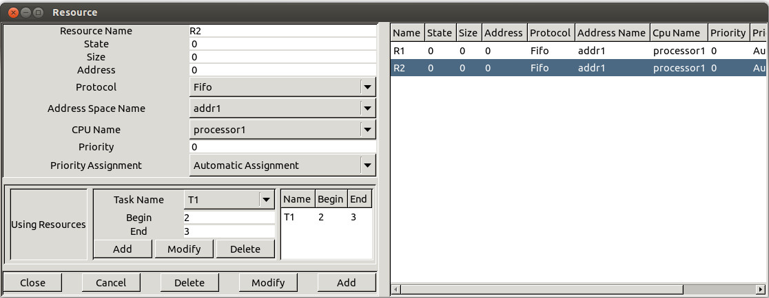

*Figure 4.1 Add a new shared resource*

Before adding a shared resource, at least one processor and one task must already exist in your project. A resource is defined by the following information :

1. An unique **name**.
2. An initial **value/state** (simular to a semaphore initial value). During a scheduling simulation, at a given time, if a resource value is equal or less than zero, the requesting tasks are blocked until the semaphore/shared resource is released. An initial value equal to 1 allows you to design a shared resource that is initially free and that can be used by only one task at a given time.
3. A **protocol.** Currently, you can choose between PCP (for Priority Ceiling Protocol), PIP (for Priority Inheritance Protocol) or "No protocol". With PCP or PIP, accessing shared resources may change task priorities [[SHA 90]](http://beru.univ-brest.fr/%7Esinghoff/cheddar/publications/basic-rts.html). The "No protocol" just means that no task prioriy will be changed at accessing the shared resource.
4. A **processor name.** Each shared resource has to be hosted by a given processor.
5. A **priority.** ...
6. A **priority assignment.** ...:
   * automatic assignment ...
   * manual assignment ...
7. Finally, we must give information on tasks that need the resource. Tasks hold resources in critical section. Each critical section has to be defined by :
   * The task name requiring the shared resource.
   * The start time of the critical section.
   * The end time of the critical section.

Of course, you can define several critical sections for a given task of a given shared resource.

By default, shared resources analysis tools are not included in the scheduling simulation engine of Cheddar. See "Tools/Scheduling/Options" if you want to take care of shared resources during scheduling simulation and if you want to display shared resources time line. Blocking time on shared resources can be computed from scheduling simulation analysis if scheduling simulation is invoked from the sub-menu "Tools/Scheduling/Scheduling Simulation".

Finally, from the "Tools/Resources/Bound on Blocking time" sub-menu, you will find services to compute bounds on blocking time of each tasks. These bounds are computed without assumption on the scheduling actually generated for the analyzed system. To compute blocking time bound, shared resources have to used PCP or PIP protocols.

**IV.2 Task precedencies : the dependencies.**

With Cheddar, dependencies are links between at least two tasks. There are three different types of dependencies : precedencies, message and buffer dependencies. Precendencies express order constraints between end or beginning of task execution. Message dependencies express relationships between a sender and a receiver task of a given message. Buffer dependencies express relationships between producer and consumer of data in a given buffer.

To create a dependency, choose "Edit/Entities/Softwares/Dependencies". The window of figure 4.2 is then displayed :

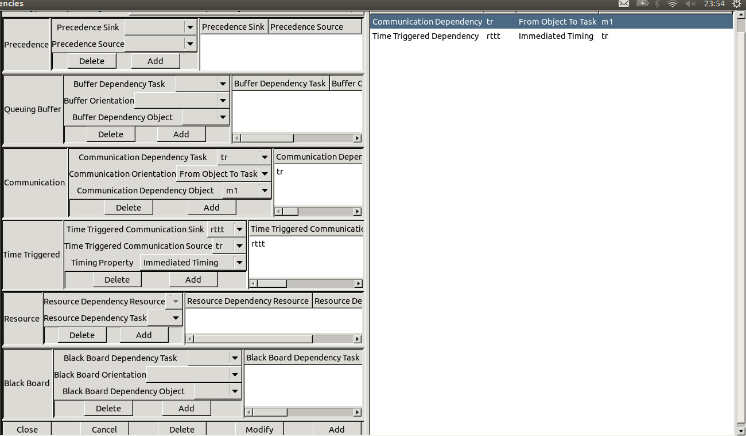

*Figure 4.1 Add a new dependency*

A dependency is characterized by:

1. The **type of dependency**. We distinguish:
   * precedence dependency ...
     + precedence_sink ...
     + precedence_source ...
   * queuing buffer dependency ...
     + buffer dependent task ...
     + buffer orientation ...
     + buffer dependency object ...
   * communication dependency ...
     + communication dependent task ...
     + communication orientation ...
     + communication dependency object ...
   * time triggered communication dependency ...
     + sampled timing ...
     + immediate timing ...
     + delayed timing ...
   * resource dependency ...
     + resource dependency resource ...
     + resource dependency task ...
   * black board buffer dependency ...
     + black board dependent task ...
     + black board orientation ...
     + black board dependency object ...

**IV.3 Buffer analysis tools.**

Cheddar allows you to define buffers shared by tasks. If you want to define a buffer, a processor, an address space and a least one task have to be defined before. A buffer can be added to a Cheddar project with the submenu "Edit/Entities/Softwares/Buffer". The window below is then displayed :

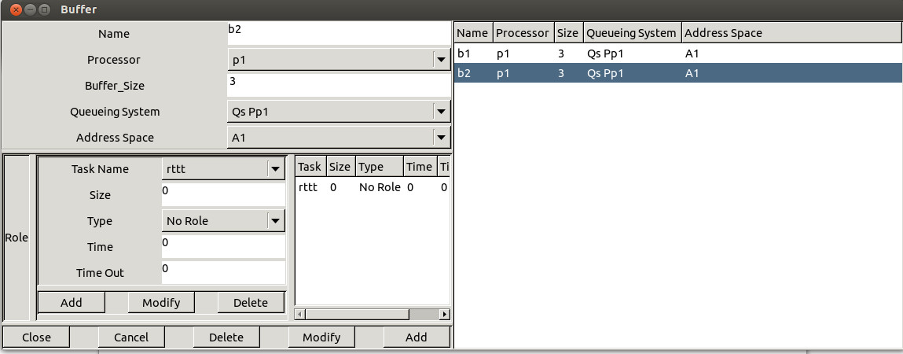

*Figure 4.2 Add a new buffer*

* A buffer has a unique **name**, **size** and is hosted by a **processor** and an **address space**.
* A **queueing system model** is assigned to each buffer. This queueing system model describes the way buffer read and write operations will be done at simulation time. This information is also used to apply buffer feasibility tests.
* **A list of tasks** which access to the buffer (read or write operations). Two type of tasks can access a buffer : **producers** and **consumers** . We suppose that a producer/consumer writes/reads a fixed size of information in the buffer. For each producer or consumer, the size of the information produced or consummed have to be defined. The time of the read/write operation is also given : this time is relative to the task capacity (eg. if T2 consumes a message at time 2, it means that the message will be removed from the buffer when T2 run the 2nd unit of time of its capacity).

Like tasks, two kinds of tools can be invoked by the user from a buffer : **simulation** and **feasibility** tools. At first, the simulation of the task scheduling can help the user to see how the buffer is filled or not with messages (see "Tools/Buffer/Buffer simulation" submenu). In this case, a scheduling simulation must be previously run. The result is then displayed in a window as below :

Buffer Feasibility mainly consists of computing buffer bounds. Bounds computed here suppose that each task that is defined as "producer", produces one message per periodic activation. In the same manner, each "consumer" extracts one message during each of its periodic activation.

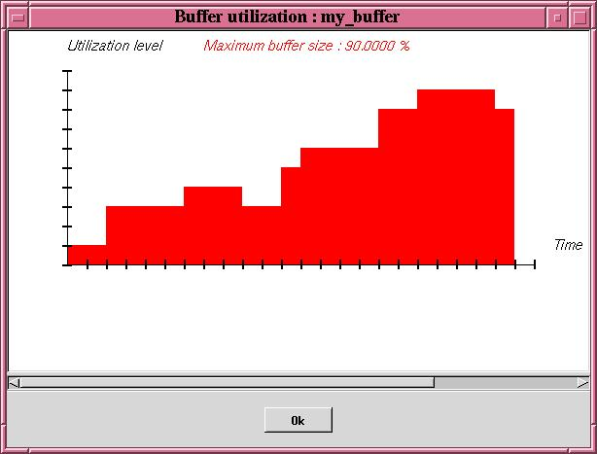

*Figure 4.3 Display buffer utilization factor computed from scheduling simulation*

The picture contains the buffer utilization level for each time.   
Second, the feasibility tool provides a way to compute bounds on buffer utilization level. At the time we write this User's guide, bounds do not depend on the type of the scheduler. Bounds can be computed from the "Tools/Buffer/Buffer feasibility" submenu.

**IV.4 Message scheduling services.**

http://beru.univ-brest.fr/%7Esinghoff/cheddar/gif/blueline.gif

**V. Multiprocessor scheduling services.**

Multiprocessor system is good for heavy computing demands. It is sometimes the only way to provide sufficient processing power to meet critical real-time deadlines. In general multiprocessor systems are also more reliable than uni-processor systems. Scheduling of multiprocessor systems is proven to be a NP-hard (Non-deterministic Polynomial-time) problem [[LEU 82]](http://beru.univ-brest.fr/%7Esinghoff/cheddar/publications/basic-rts.html). The complexity class NP is the set of decision problems that can be solved by a non-deterministic machine in polynomial time. The complexity theory is part of the theory of computation dealing with the resources required during computation to solve a given problem. The most common resources are time (how many steps does it take to solve a problem) and space (how much memory does it take to solve a problem). Other resources can also be considered, such as how many parallel processors are needed to solve a problem in parallel. There are many scheduling heuristics to solve this. Rate-monotonic scheduling is good for numerous reasons: Rate-monotonic algorithm is optimal for fixed priority assignment of periodic tasks on a processor so it’s easy to design predictable real-time system. Also it is easy to implement and it takes minimal scheduling overhead.   
  
Cheddar has four algorithms: RMNF, RMFF, RMBF, RMST and RMGT. Each of these are off-line schemes, so the entire task set must be known before starting task assignment. Bounds for functions are calculated using http://beru.univ-brest.fr/%7Esinghoff/cheddar/ug/ug_v3/Nopt.jpg.   
  
**Rate-Monotonic-Next-Fit** [**[SON 93]**](http://beru.univ-brest.fr/%7Esinghoff/cheddar/publications/basic-rts.html)  
  
Upper bound for this algorithm is 2.67. Tasks are sorted in non-decreasing order of periods. Then tasks are placed on processors, according to the IP Condition (Increasing Period). The first task is placed on the first processor. Then the second task is placed on the first processor, if it meets the IP Condition. Otherwise it is placed on a new processor. This continues until all tasks are scheduled.   
  
**Rate-Monotonic-First-Fit** [**[SON 93]**](http://beru.univ-brest.fr/%7Esinghoff/cheddar/publications/basic-rts.html)  
  
The upper bound for this algorithm is 2.33 [[SON 93]](http://beru.univ-brest.fr/%7Esinghoff/cheddar/publications/basic-rts.html) (original study by Liu and Dhall had a wrong bound of 2.23). Tasks are sorted in non-decreasing order of periods. The IP Condition is used to verify teh schedulability of tasks on processors. The first task is placed on the first processor. Then the second task is placed on the first processor, if it meets the IP Condition. Otherwise it is placed on a new processor. The third task is tried to be placed on the first processor according to the IP Condition. If it does not meet the condition, the task is tried to be placed on the second processor. Otherwise a new processor is selected for the third task…   
  
**Rate-Monotonic-Best-Fit** [**[SON 93]**](http://beru.univ-brest.fr/%7Esinghoff/cheddar/publications/basic-rts.html)  
  
The upper bound for this algorithm is 2.33. Tasks are sorted in non-decreasing order of periods. The first task is placed on the first processor. For the second task, the function checks all processors, whether they meet the IP Condition. For processors that satisfy the condition, the algorithm checks the number kj of tasks already assigned to each processor j, and computes Uj, the total utilization of the kj tasks. And the task is assigned to the processor that has the smallest value. If the condition is not met, a new processor is selected for the task.   
  
**Rate-Monotonic Small-Tasks** [**[BUR 94]**](http://beru.univ-brest.fr/%7Esinghoff/cheddar/publications/basic-rts.html)  
  
The upper bound for RMST is http://beru.univ-brest.fr/%7Esinghoff/cheddar/ug/ug_v3/RMSTbound.jpg, a = max Ui, i = 1,…,K and U is utilization of all tasks. Tasks are sorted in increasing Si. Si = log2(Ti). The main idea of RMST is to minimize the value of b for each processor. ß = max Si – min Si, 1= i =K.   
  
**Rate-Monotonic General-Tasks** [**[BUR 94]**](http://beru.univ-brest.fr/%7Esinghoff/cheddar/publications/basic-rts.html)  
  
The upper bound for RMGT is 1.75. RMGT uses the RMST algorithm for task s = 1/3 and First-Fit heuristics for the rest of the tasks.   
  
**Example of use :**

1. First, Define cores for processors. They have to be of Rate Monotonic type.   
     
   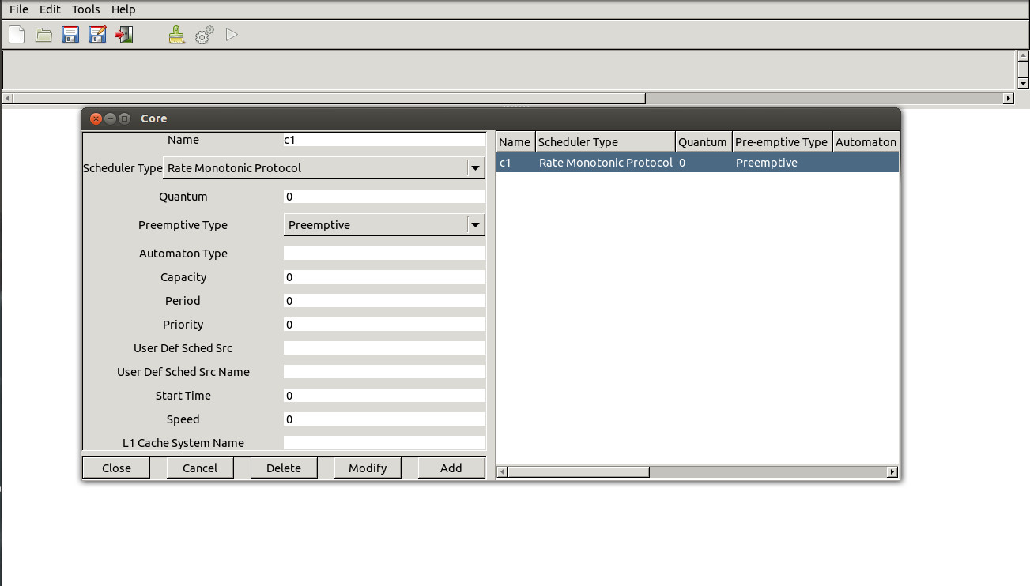
2. Second, Define processors for tasks.   
     
   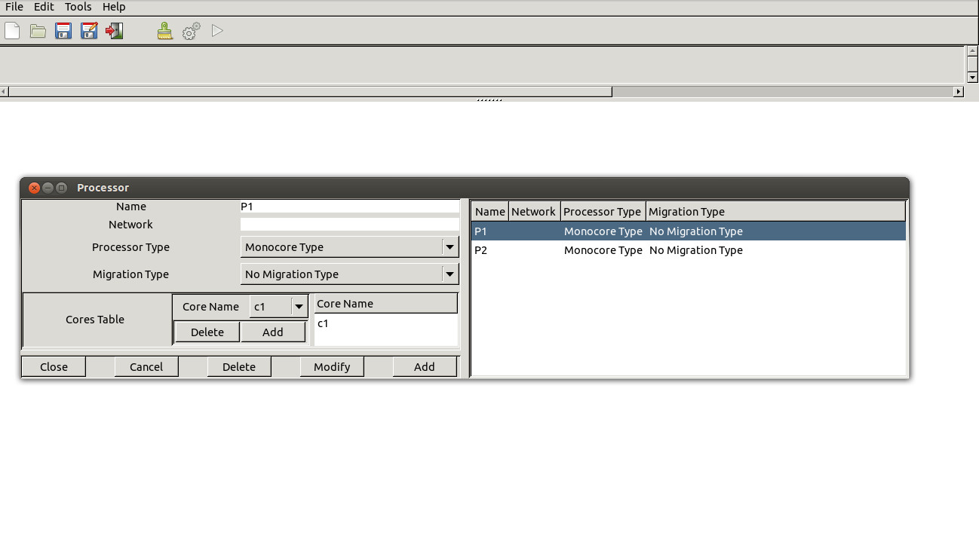
3. Third, Define Address space used by tasks.   
     
   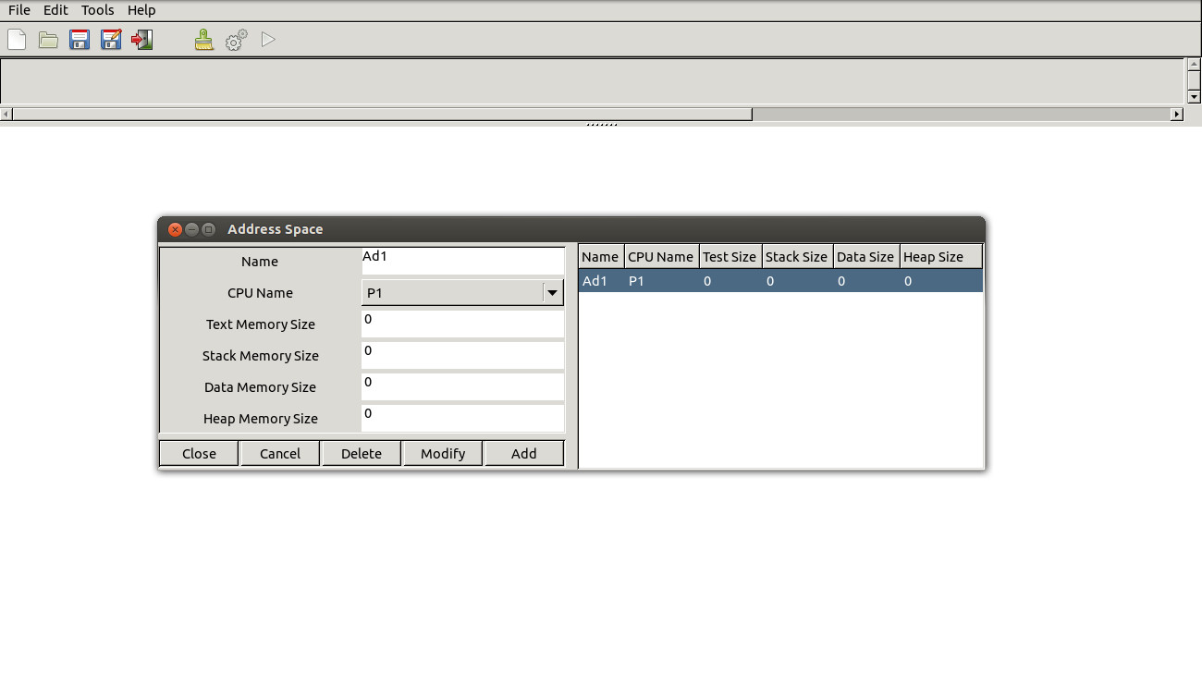
4. Then, Define tasks (host tasks on any processor and address space)   
     
   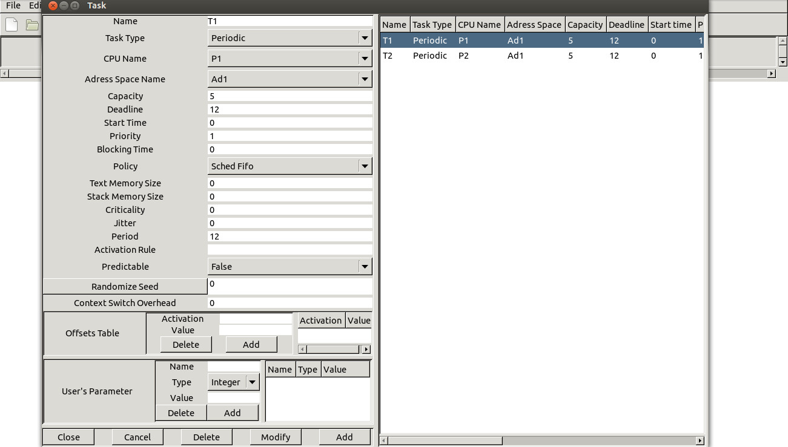
5. Finally, compute partitioning, with the submenu "Tool/Scheduling/Partition/With Small Task". :   
     
   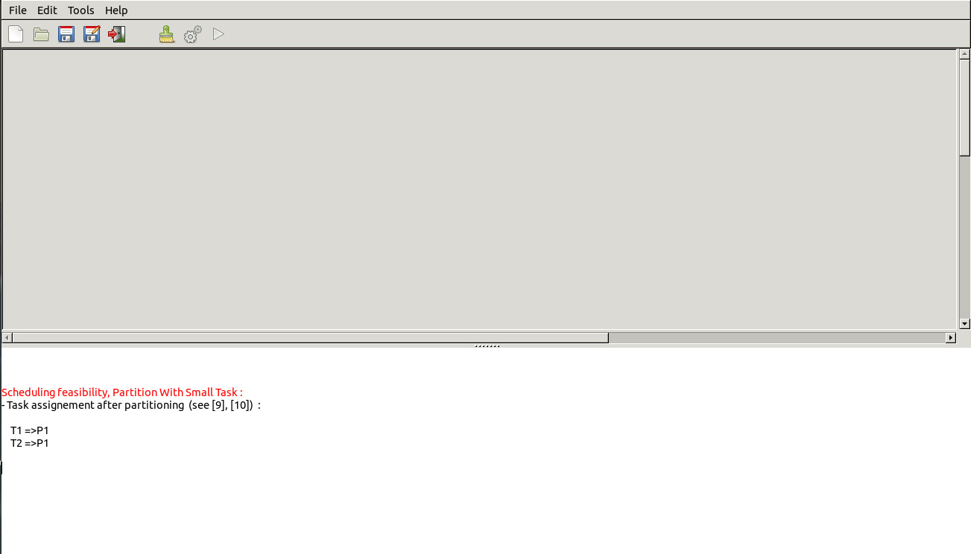

http://beru.univ-brest.fr/%7Esinghoff/cheddar/gif/blueline.gif

**VI. User-defined simulation code : how to run simulations of specific systems.**

Usual feasibility tests are limited to only few task models (mainly periodic tasks) and to only few schedulers. When an application built with a particular task activation pattern or scheduled with a particular scheduler has to be checked, feasibility tests are not necessarily available. In this case, the only solution consists in analyzing the scheduling simulation. Cheddar allows the user to design and easily build framework extensions to do simulation of user-defined schedulers or task activation patterns. By easy, we mean quickly write and test framework extensions without a deep understanding of the framework design and of the Ada language. We propose the use of a simple language to describe framework extensions. Framework extensions are interpreted at simulation time. As a consequence, they can be changed and tested without recompiling the framework itself.   
  
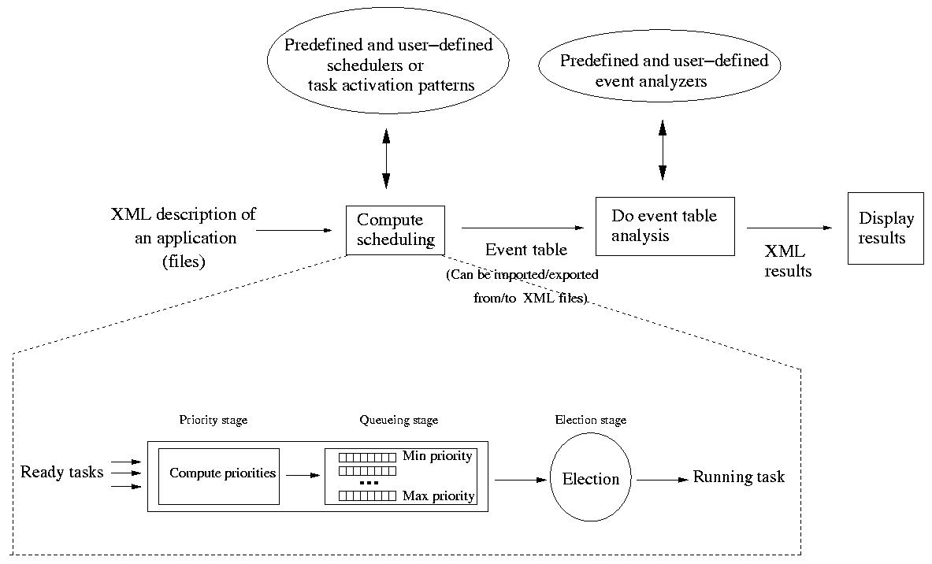

*Figure 5.1 How a user-defined code is run by the scheduling engine*

Figure 5.1 gives an idea on the way the simulation engine is implemented in the framework. Running a simulation with Cheddar is a three-step process.   
  
The first step consists of computing the scheduling : we have to decide which events occur for each unit of time. Events can be allocating/releasing shared resources, writing/reading buffers, sending/receiving messages and of course running a task at a given time. At the end of this step, a table is built which stores all the generated events. The event table is built according to the XML description file of the studied application and according to a set of task activation patterns and schedulers. Usual task activation patterns and schedulers are predefined in the Cheddar framework but users can add their own schedulers and task activation patterns.   
  
In the second step, the analysis of the event table is performed. The table is scanned by "event analyzers" to find properties on the studied system. At this step, some standard information can be extracted by predefined event analyzers (worst/best/average blocking time, missed deadlines ..) but users can also define their own event analyzers to look for ad-hoc properties (ex : synchronization constraints between two tasks, shared resources access order, ...). The results produced during this step are XML formatted and can be exported towards other programs.   
  
Finally, the last step consists of displaying XML results in the Cheddar main window (see Figure 1.4).

**VI.1 Defining new schedulers or task activation patterns.**

Now, let's see how user-defined schedulers or task activation patterns can be added into the framework. Basically, all tasks are stored in a set of arrays. Each array stores a given information for all tasks (ex : deadline, capacity, start time, ...). The job of a scheduler is to find a task to run from a set of ready tasks. To achieve this job, Cheddar models a scheduler with a 3 stages pipe-line which is similar [to the POSIX 1003.1b scheduler (see [GAL 95])](http://beru.univ-brest.fr/%7Esinghoff/cheddar/publications/basic-rts.html). These 3 stages are :

1. **The priority stage.** For each ready task, a priority is computed.
2. **The queueing stage.** Ready tasks are inserted into different queues. There is one queue per priority level. Each queue contains all the ready tasks with the same priority value. Queues are managed like POSIX scheduling queues : if a quantum is associated with the scheduler, queues work like the SCHED_RR scheduling queueing policy. Otherwise, the SCHED_FIFO queueing policy is applied.
3. **The election stage.** The scheduler looks for the non empty queue with the highest priority level and allocates the processor to the task at the head of this queue. The elected task keeps the processor during one unit of time if the designed scheduler is preemptive or during all its capacity if the scheduler is not preemptive.

Defining a new scheduler is simply giving piece of code for some of the pipe-line stages we described above. Each of these stages can be defined by a user without the need to have a deep knowledge of the way the scheduling simulator works. User-defined schedulers are stored in text files. These files are organized in several **sections** :

* The **start** section. In this section, you may declare variables needed to schedule your tasks. Many variables are already predefined in Cheddar. Some of them are those defined at task/processor/buffer/message definition (ex : period, deadline, capacity ...). This set of predefined variables can be extended with the "Edit/Update Tasks" submenu (see user-defined parameters). The others are managed by the simulator engine and describe the state of tasks/processors/buffers/messages at simulation time. See section [**VI.5**](http://beru.univ-brest.fr/%7Esinghoff/cheddar/ug/ug_v3/cheddar-r3.html#Ref6.5) for a list of all predefined variables. All variables used in a scheduler should have a type. The framework provides two type families : scalar types and arrays. One can define variable with scalar type of **double, integer, boolean, string** and also of **random** (a random is a type which allows the user to generate ramdom values). An array is a type which stores one scalar data per task, message, buffer or shared resource. Arrays are declared as usual Ada Table. Vectorial operations can be done on this kind of variable.
* The **priority** section. The section contains the code necessary to compute task priorities. The code given here is called each time a scheduling decision has to be made (at each unit of time for preemptive scheduler and when a task has run during all its capacity for non preemptive scheduler). The code given here can be composed of many differents statements described in section [**VI.5**](http://beru.univ-brest.fr/%7Esinghoff/cheddar/ug/ug_v3/cheddar-r3.html#Ref6.5)
* The **election** section. This section just decides which task should receive the processor for next units of time. This section should only contain one **return** statement.
* The **task activation** section. This section describes how tasks could be activated during a simulation. In Cheddar, 3 kinds of tasks exists : aperiodic tasks which are activated only one time and periodic or poissons process tasks which are activated several times. In the case of periodic tasks, two successive task activations are delayed by an amount of fixed time called period. In the case of poisson process tasks, two successive task activations are delayed by an exponential random delay. The task activation section allows you to define new kinds of task activation patterns (ex : sporadic task, randomly activated task, burst of activations, ...). .

In the sequel, we first give you some simple examples of user-defined schedulers. Then, we explain how to use this kind of scheduler to do scheduling simulation with Cheddar. The list of statements and the list of predefined variables is given at the end of this section.

**VI.1 Examples of user-defined schedulers.**

In this section, we give some user-defined scheduler examples. We first show that a user-defined scheduler can be built with two kinds of statements : high-level and low-level statements. Second, we present how to add new task parameters with User's defined task parameters.

**VI.1.1 Low-level statements versus High-level statements**

Now let's see some very simple user-defined schedulers. The most simple user-defined scheduler can be defined like below :

|  |
| --- |
| election_section:  return min_to_index(tasks.period); end section; |

*Figure 5.2 a simple Rate Monotonic scheduler*

This first example shows you how to give the processor to the task with the smallest period. This scheduler is equivalent to the Rate monotonic implemented into Cheddar. **tasks.period** is a predefined variable initialized at task definition time by the user. To implement a Rate Monotonic scheduler, no dynamic priorities are computed and no variable is necessary. Then, the scheduler designer does not have to redefine the **start** and **priority** sections. The only section which is defined is the **election** one. The **election** section contains an unique **return** statement to inform the scheduling simulator engine which task should be run for the next unit of time. The return statement uses the high level **min_to_index** operator. This operator scans the task array to find the ready task with the minimum value for the variable **tasks.period**. In Cheddar, the scheduler designer can use two kinds of statements : high-level and low-level statements. High level statements like **min_to_index**, hides the data type organization of the scheduling simulator engine. For example, the scheduler designer do not need to give statement into its user-defined scheduler to scan manually the task array. Writing a scheduler with high-level statements is then easy work. On the contrary, low-level statements assume that the user has a deeper idea of the design of the scheduling engine simulator. By the way, these statements are sometimes necessary when the scheduler designer wants to code a too much specific scheduler.   
  
Now let's see how to define an EDF like scheduler :

|  |
| --- |
| 1 start_section: 2       dynamic_priority : array (tasks_range) of integer; 3 end section; 4 5 priority_section: 6       dynamic_priority := tasks.start_time + tasks.deadline 7          + ((tasks.activation_number-1)*tasks.period); 8 end section; 9 10 election_section: 11      return min_to_index(dynamic_priority); 12 end section; |

*Figure 5.3 an EDF like scheduler using vectorial operators*

EDF is a dynamic scheduler which computes a dynamic priority for each task. This dynamic priority is in fact a deadline. EDF just gives the processor to the task with the shortest deadline. In our example, this deadline is stored in a variable called **dynamic_deadline**. Since we need one value per task, the type of this variable is **integer array**. With this example the **priority_section** is not empty any more and contains (lines 5 to 7) the necessary code to compute EDF dynamic priorities. You should notice that the code in line 6/7 is in fact a vectorial operation : the arithmetic operation to compute the deadline is done for each item of the table **dynamic_priority** ranging from 1 to **nb_tasks** (**nb_tasks** is a static predefined variable initialized by the number of tasks in the current processor). To compute the dynamic priorities of our example, we used many predefined variables :

* **tasks.deadline, tasks.start_time and tasks.period** : they are the deadline, start time and period values given by the user at task definition time (in the window Edit/Update tasks).
* **tasks.activation_number** : it's a variable updated by the simulation engine. The simulator increments this variable each time a periodic or a poisson process task starts a new activation. For instance, if **tasks.activation_number(i)** is equal to 3, it means that the task **i** has started its 4th activation.

You can find in [**VI.5**](http://beru.univ-brest.fr/%7Esinghoff/cheddar/ug/ug_v3/cheddar-r3.html#Ref6.5) a list of all predefined variables and all available statements you can used to build your user-defined scheduler.   
  
  
The example of the Figure 5.3 is built with vectorial operators : each arithmetic operation is done for all the tasks of the system. The scheduler designer does not need to take care of the task array and just gives rules to computed the EDF dynamic deadline. As **max_to_index/min_to_index**, these statements are High-level ones because they do not required to directly access the data type organization of the scheduling engine of Cheddar (mainly the task arrays).   
  
Now, let's see a third example:

|  |
| --- |
| start_section:  to_run : integer;     current_priority : integer;    priority_section:    current_priority:=0;    for  i in tasks_range  loop          if (tasks.ready(i) = true) and (tasks.priority(i)>current_priority)                    then to_run:=i;                         current_priority:=tasks.priority(i);         end if;     end loop; end section;  election_section:  return to_run; end section; |

*Figure 5.4 Building a user-defined with low-level statement*

This scheduler looks for the highest priority ready task of a processor and is fully equivalent to the scheduler described by :

|  |
| --- |
| election_section:       return max_to_index(tasks.priority); end section; |

*Figure 5.5 a HPF scheduler built with hight-level statements*

but, in the example of Figure 5.4, the code scans itself the task array to find a ready task to run. To achieve this, the example of Figure 5.4 is built with low-level instructions : a **for** loop and an **if** statement. The **priority_section** is then composed of a loop that tests each task entry. This loop is made with a **for** statement, a loop that runs the inner statement for each task defined in the task array. Contrary to a high-level implementation, a scheduler made of low-level statements has to carry out more tests. For instance, the example of the Figure 5.4 checks with the **ready** dynamic variable if tasks are ready at the time the scheduler is called. Low-level scheduler are then more complicated and more difficult to test. The reader will find some tips to help test complicated user-defined schedulers in section [**VI.3**](http://beru.univ-brest.fr/%7Esinghoff/cheddar/ug/ug_v3/cheddar-r3.html#Ref6.3) .

**VI.1.2 User-defined scheduler built with User's defined Task Parameters**

In the previous examples, the data used to built user-defined schedulers were either static variables initialized at task definition time, either dynamic variables predefined or declared in the **start** section. A last type of data exists in Cheddar : User's defined task parameters. This kind of data are static ones and are defined at task definition time. User's defined task parameters allow the user to extend the set of static variables. Since they describe new task parameters, User's defined task parameters are table type. User's defined task parameters can be boolean, integer, double or string table type. To define User's defined task parameters, you have to update the third part of the entity task. Use the submenu "Edit/Entities/Software/Task" :

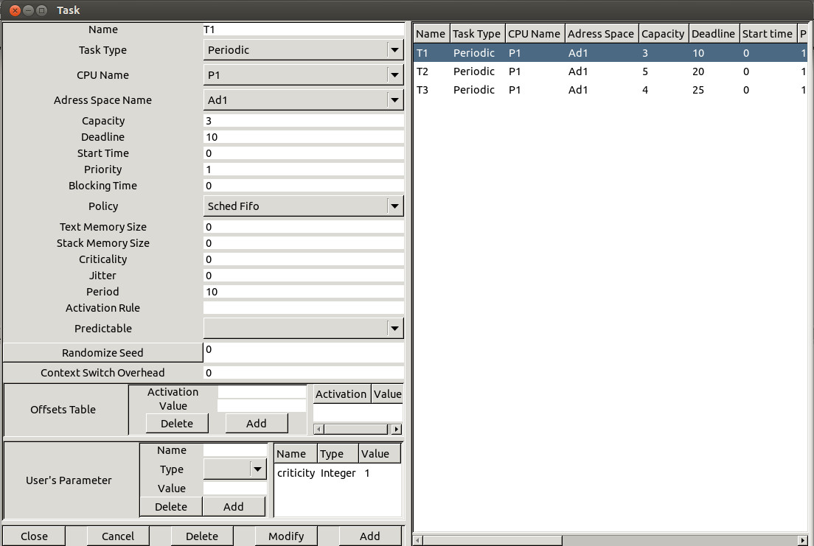

*Figure 5.6 Adding an Users's Defined Task Parameter*

The example above shows you a system composed of 3 tasks (T1, T2 and T3) where a criticity level is defined. Like usual task parameters, you should give a value to a User's defined task parameter (ex : the criticity level for task T1 is 1) but you also have to set a type to the parameter (**integer** in our example). When tasks are created, as usually, you can call the scheduling simulation services of Cheddar. The next window is a snapshoot of the resulting scheduling of our example composed of 3 tasks scheduled according to their criticity level. (T2 is the most critical task and T1 the less critical).

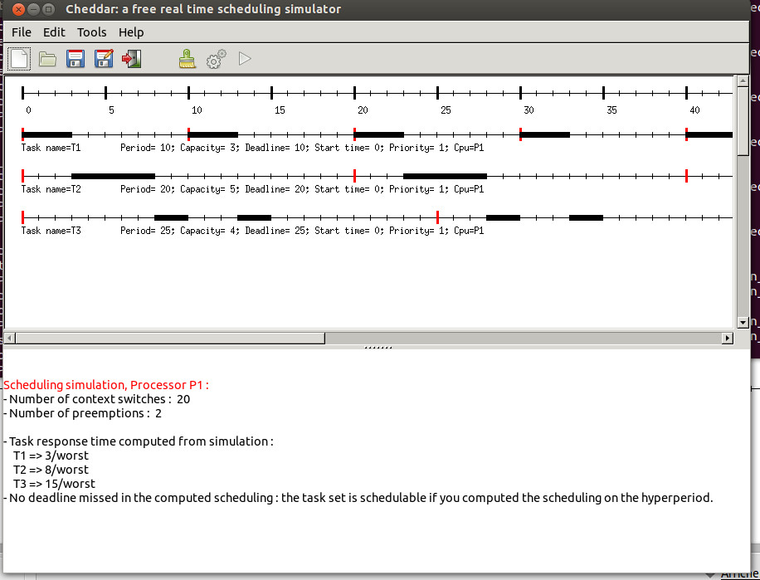

*Figure 5.7 Scheduling according to a criticity level.*

To conclude this chapter, let's have a look to a more complex example of user-defined scheduler which summarises all the features presented before. This example is [an ARINC 653 scheduler (see [ARI 97]).](http://beru.univ-brest.fr/%7Esinghoff/cheddar/publications/basic-rts.html) An ARINC 653 system is composed of several partitions. A partition is a unit of software and is itself composed of processes and memory spaces. A processor can host several partitions so that two levels of scheduling exist in an ARINC653 system : partition scheduling and process scheduling.

1. **Process scheduling.** In one partition, process are scheduled according to their fixed priority. The scheduler is preemptive and always gives the processor to the highiest fixed priority task of the partition which is ready to run. When several tasks of a partition have the same priority level, the oldest one is elected.
2. **Partition scheduling.** Partitions share the processor in a predefined way. On each processor partitions are activated according to an activation table. This table is built at design time and defines a cycle of partition scheduling. The table describes for each partition when it has to be activated and how much time it has to run for each of its activation.

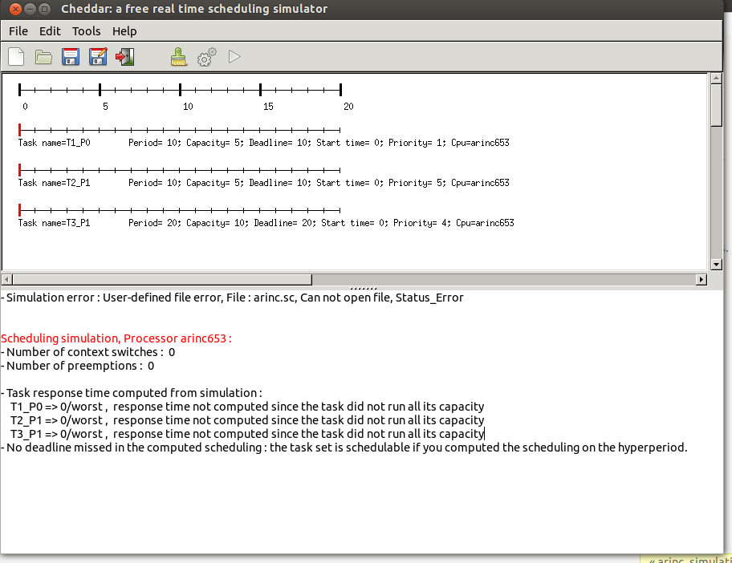

*Figure 5.8 An example of ARINC 653 scheduling*

The Figure 5.8 displays an example of ARINC 653 scheduling (see the XML project file project_examples/arinc653.xml). The studied system is made of 3 tasks hosted by one processor. The processor owns 2 partitions : partition number P0 and partition number P1. The task T1 runs in partition P0 and the two others run in partition P1. Each task has a fixed priority level : the T1 priority is 1, the T2 priority is 5 and the T3 priority is 4. The cyclic partition scheduling should be done so that P0 runs before P1. In each cycle, P0 should be run during 2 units of time and P1 should run during 4 units of time. The user-defined scheduler source code used to compute the scheduling displayed in Figure 5.8 is given below :

|  |
| --- |
| start_section:      partition_duration :  array (tasks_range) of integer;      dynamic_priority :  array (tasks_range) of integer;      number_of_partition : integer :=2;      current_partition : integer :=0;      time_partition : integer :=0;      i : integer;       partition_duration(0):=2;      partition_duration(1):=4;      time_partition:=partition_duration(current_partition); end section;  priority_section:      if time_partition=0          then  current_partition:=(current_partition+1)             mod number_of_partition;                time_partition:=partition_duration(current_partition);      end if;       for i in tasks_range loop          if tasks.task_partition(i)=current_partition                    then dynamic_priority(i]:=priority(i);                                 else  dynamic_priority(i):=0; tasks.ready(i):=false;          end if;       end loop;      time_partition:=time_partition-1; end section;  election_section:          return max_to_index(dynamic_priority); end section; |

*Figure 5.9 Processes and partitions scheduling into an ARINC 653 system*

In this code, **tasks.task_partition** is a User's defined task parameter. **tasks.task_partition** stores the partition number hosting the associated task. The variable **partition_duration** stores the partition cyclic activation table.

**VI.2 Scheduling with specific task models.**

In the same way you can define specific schedulers, you can also define specific task activation patterns. By default, 3 kinds of task activation pattern are defined in Cheddar :

* Periodic task : a fixed amount of time exists between two successive task activations.
* Aperiodic task : the task is activated only once at a given time.
* Poisson process task : tasks are activated several times and the delay between two successive activations is a random delay. The static variable period in this case is the average time between two successive activations. The delay between activations is generetad according to a random poisson process.

If the application you want to study can not be modeled with this 3 kinds of activation rules above, a possible solution is to explain your own task activation pattern with a user-defined scheduler. The description of task activation pattern is done in **.sc** files in a particulary section which is called **task_activation_section**. In this section, you can define named activation rules with **set** statements. The set statement just link a name/identifier (the left part ot the set statement) and an expression (the right part of the set statement). The expression explains the amount of time the scheduling simulator engine has to wait between two activations of a given task.

|  |
| --- |
| start_section:  gen1 : random;  gen2 : random;  exponential(gen1, 200);  uniform(gen2, 0, 100); end section;  election_section:  return max_to_index(tasks.priority); end section;  task_activation_section:  set activation_rule1 10;  set activation_rule2 2*tasks.capacity;  set activation_rule3 gen1*20;  set activation_rule4 gen2; end section; |

*Figure 5.10 Defining new task activation patterns : how to run simulation with specific task models*

The example of the Figure 5.10 describes a Highest Priority First scheduler which hosts tasks activated with different patterns. Each pattern is described by a set statement :

* The pattern activation_rule1 describes periodic tasks with a period equal to 10.
* The pattern activation_rule2 describes periodic tasks with a period equal to twice their capacity.
* The pattern activation_rule3 describes randomly activated tasks. Two successive activations are delayed by an amount of time which is randomly computed. Delays are computed according to a random exponential distribution pattern with a mean value of **400**. 400 is then the average period value of the tasks. The seed used during random delay generation depends on the scheduling options set at simulation time (see section [**I.3**](http://beru.univ-brest.fr/%7Esinghoff/cheddar/ug/ug_v3/cheddar-r3.html#Ref1.3) ) : the user can choose to associate a seed per task or a seed for all the tasks. Seeds can be initialized in a predictable way or in an unpredictable way. In the case of a predictable seed, the random generator is initialized with the seed value given at task definition time or in the scheduling option window. In the case of an unpredictable seed, the seed is initialized by the "gettimeofday" at simulation time.
* The pattern activation_rule4 describes randomly activated tasks. Two successive activations are delayed by an amount of time that is randomly computed. Delays are computed according to a random uniform distribution pattern with a mean value of **50**. At each periodic task activation, the period can have a value between 0 and 100. The seed used during random delay generation is managed in the same way than activation_rule3.

When task activation rules are defined, task activation names (ex : activation_rule1) have to be associated with "real" task. The picture below shows you an "Edit/Entities/Software/Task" window :

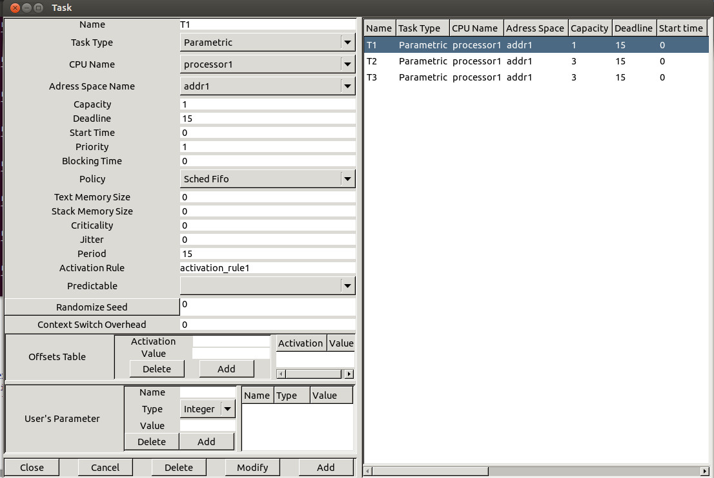

*Figure 5.11 Assigning activation rules to tasks*

In this example, the task activation rule activation_rule1 is associated with task T1. The task activation rule activation_rule2 is associated with task T2. The task activation rule activation_rule3 is associated with tasks T3.

**VI.3 Running a simulation with a user-defined scheduler.**

Let's see how to run a simulation with one or several user-defined schedulers. First, you have to add a scheduler by selecting the submenu "Edit/Entities/Hardware/Core". The following window is then launched :

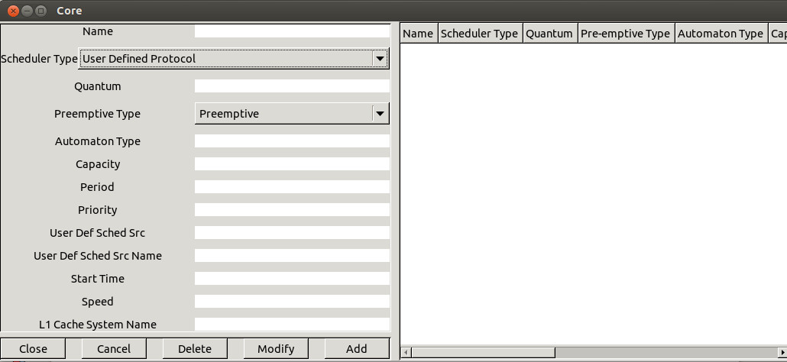

*Figure 5.13 Define a core with a user-defined scheduler*

To add a user-defined scheduler into a Cheddar project, select the right item of the Combo Box and give a name to your scheduler. You should then provide the code of your user-defined scheduler. This operation can be done by pushing the "Read" button.   
In this case, the following window is spawned and you should give a file name containing the code of your user-defined scheduler :

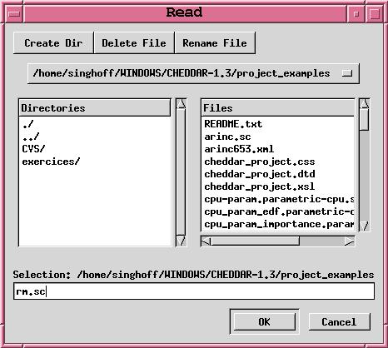

*Figure 5.14 Selecting the .sc file which contains the user-defined scheduler*

By convention, files that contain user-defined scheduler code should be prefixed by **.sc**. For example, the file rm.sc in our example should almost contain an **election** section and of course, can also contain a **start** and a **priority** sections. When a processor is defined, you have to add tasks on it. To do so, select the submenu "Edit/Entities/Software/Task" like in section **I**. Just place the task on the previously defined processor. Finally, you can run scheduling simulations as the usual case.   
  
Since a user-defined scheduler is also a piece of code, you sometimes need to debug it. To do so, you can use the following tips :

* First, a special instruction can be used to display the value of a variable on the screen : the **put** statement. For instance, running the following user-defined code will display the value of the dynamic variable **to_run** each time the scheduler is called :

|  |
| --- |
| --!TRACE  start_section:  to_run : integer;  current_priority : integer;  end section;  priority_section:  current_priority:=0;  for i in tasks_range loop   if  (tasks.ready(i)=true) and (tasks.priority(i)>current_priority)              then to_run:=i;                       put(to_run);                   current_priority:=tasks.priority(i);  end if;  end loop;  end section;  election_section:  return to_run;  end section; |

*Figure 5.15 Using the put statement*

* A second tip can help you to test if the syntax of your user-defined scheduler is correct. In all **.sc** file, you can add the line **--!TRACE** anywhere. If you add this line, the parser will give extra information during the syntax analysis of your user-defined scheduler. It's useful if you want to test a **.sc** file before using it in a Cheddar project file. You can also test it with **sc**, a program designed to read, parse and check **.sc** files.

**VI.4 Looking for user-defined properties during a scheduling simulation.**

|  |
| --- |
| start_section:  i : integer;  nb_T2 : integer;  nb_T1 : integer;  bound_on_jitter : integer;  max_delay : integer;  min_delay : integer;  tmp : integer;  T1_end_time : array (time_units_range) of integer;  T2_end_time : array (time_units_range) of integer;  min_delay:=integer'last;  max_delay:=integer'first;  i:=0;  nb_T1:=0; nb_T2:=0; end section;  gather_event_analyzer_section:  if (events.type = "end_of_task_capacity")  then  if (events.task_name = "T1")  then  T1_end_time(nb_T1):=events.time;  nb_T1:=nb_T1+1;  end if;  if (events.task_name = "T2")  then  T2_end_time(nb_T2):=events.time;  nb_T2:=nb_T2+1;  end if;  end if; end section;  display_event_analyzer_section:  while (i < nb_T1) and (i < nb_T2) loop  tmp:=abs(T1_end_time(i)-T2_end_time(i));  min_delay:=min(tmp, min_delay);  max_delay:=max(tmp, max_delay);  i:=i+1;  end loop;  bound_on_jitter:=abs(max_delay-min_delay);   put(min_delay);  put(max_delay);  put(bound_on_jitter); end section; |

*Figure 5.16 Example of user-defined event analyzer : computing task termination jitter bound*

In the same way that users can define new schedulers, Cheddar makes it possible to create user-defined event analyzers. These event analyzers are also writen with an Ada-like language and interpreted at simulation time.   
  
The event table produced by the simulator records events related to task execution and related to objects that tasks access. Event examples stored in this table can be :

* Events produced when a task becomes ready to run (event task_activation), when a task starts or ends running its capacity (events start_of_task_capacity and end_of_task_capacity),
* Events produced when a task reads or writes data from/to a buffer (events write_to_buffer and read_from_buffer),
* Events produced when a task sends or receives a message (events send_message and receive_message),
* Events produced when a task starts waiting for a busy resource (event wait_for_a_resource), allocates or releases a given resource (events allocate_resource and release_resource).

Each of these events is stored with the time it occurs and with information related to the event itself (eg. name of the resource, of the buffer, of the message, of the task ...). The event table is scanned sequentially by event analyzers. User-defined event analyzers are composed of several sections : a **start** section, a data **gathering** section and an **analyze and display** section.

* As user-defined schedulers, the **start** section is devoted to variable declarations and initializations.
* The **gathering** section contains code which is called for each item of the event table. Most of the time, this section contains statements which extract useful data from the event table, and store them for the event analyzer.
* Finally, the **display** section performs analysis on data previously saved by the **gathering** section and displays the results in the main window of the Cheddar Editor.

Figure 5.16 gives an example of user-defined event analyzer. From an ARINC 653 scheduling this event analyzer computes the minimum, the maximum and the jitter on the delay between end times of two tasks owned by different partitions (tasks T1_P0 and T2_P1 ; see Figure 5.9).

**VI.5 List of predefined variables and available statements.**

The tables below list all predefined variables that are available when you write a user-defined code:

|  |  |  |  |  |
| --- | --- | --- | --- | --- |
| ***Name*** | ***Type*** | ***Is updated by the simulator engine*** | ***Can be changed by user code*** | ***Meaning*** |
| ***Variables related to processors*** |  |  |  |  |
| nb_processors | integer | no | no | Gives the number of processors of the current analyzed system. |
| ***Variables related to tasks*** |  |  |  |  |
| tasks.period | array (tasks_range) of integer | yes | yes | Stores the value of the parameter given at task definition time. For the meaning of this variable, see section [**I**](http://beru.univ-brest.fr/%7Esinghoff/cheddar/ug/ug_v3/cheddar-r3.html#Ref1). |
| tasks.name | array (tasks_range) of string | no | no | Name of the task |
| tasks.type | array (tasks_range) of string | no | no | Type of the task (periodic, aperiodic, sporadic, poisson_process or userd_defined) |
| tasks.processor_name | array (tasks_range) of string | no | no | Stores the processor name of the cpu hosting the corresponding task. |
| tasks.blocking_time | array (tasks_range) of integer | no | yes | Stores the sum of the bounded times the task has to wait on shared resource accesses. |
| tasks.deadline | array (tasks_range) of integer | yes | yes | Stores the value of the parameter given at task definition time. For the meaning of this variable, see section [**I**](http://beru.univ-brest.fr/%7Esinghoff/cheddar/ug/ug_v3/cheddar-r3.html#Ref1). |
| tasks.capacity | array (tasks_range) of integer | yes | yes | Stores the value of the parameter given at task definition time. For the meaning of this variable, see section [**I**](http://beru.univ-brest.fr/%7Esinghoff/cheddar/ug/ug_v3/cheddar-r3.html#Ref1). |
| tasks.start_time | array (tasks_range) of integer | yes | yes | Stores the value of the parameter given at task definition time. For the meaning of this variable, see section [**I**](http://beru.univ-brest.fr/%7Esinghoff/cheddar/ug/ug_v3/cheddar-r3.html#Ref1). |
| tasks.used_cpu | array (tasks_range) of integer | yes | no | Stores the amount of processor time wasted by the associated task. |
| tasks.activation_number | array (tasks_range) of integer | yes | no | Stores the activation number of the associated task. Of course, using this variable is meaningless for aperiodic tasks. |
| tasks.jitter | array (tasks_range) of integer | yes | yes | Stores the value of the parameter given at task definition time. For the meaning of this variable, see section [**I**](http://beru.univ-brest.fr/%7Esinghoff/cheddar/ug/ug_v3/cheddar-r3.html#Ref1). |
| tasks.priority | array (tasks_range) of integer | yes | yes | Stores the value of the parameter given at task definition time. For the meaning of this variable, see section [**I**](http://beru.univ-brest.fr/%7Esinghoff/cheddar/ug/ug_v3/cheddar-r3.html#Ref1). |
| tasks.used_capacity | array (tasks_range) of integer | yes | no | This variable stores the umount of time unit the task had consumed since its last activation. When tasks.used_capacity reaches tasks.capacity, the task stops to run and waits its next activation |
| tasks.rest_of_capacity | array (tasks_range) of integer | yes | no | For each task activation, this variable is initialized to the task capacity each time the task starts a new activation. If rest_of_capacity is equal to zero, the task has over its its current activation and then task is blocked upto its next activation. |
| tasks.suspended | array (tasks_range) of integer | yes | yes | This variable can be used by scheduler programmers to block a task : remove a task from schedulable tasks. |
| nb_tasks | integer | no | no | Gives the number of tasks of the current analyzed system. |
| tasks.ready | array (tasks_range) of boolean | yes | no | Stores the state of the task : this boolean is true if the task is ready ; it means the task has a capacity to run, does not wait for a shared resource, does not wait for a delay, does not wait for a offset constraint and does not wait for a precedency constraint. |
| ***Variables related to messages*** |  |  |  |  |
| nb_messages | integer | no | no | Gives the number of messages of the current analyzed system. |
| messages.name | array (messages_range) of string | no | no | Gives the names of each message. |
| messages.jitter | array (messages_range) of integer | no | no | Jitter on the time the periodic message becomes ready to be sent. |
| messages.period | array (messages_range) of integer | no | no | Gives the sending period if the message is a periodic one. |
| messages.delay | array (messages_range) of integer | no | no | time needed by a message to go from the sendrer to the receiver node. |
| messages.deadline | array (messages_range) of integer | no | no | Stores the deadline if the message has to meet one. |
| messages.size | array (messages_range) of integer | no | no | Stores the size of the message. |
| messages.users.time | array (messages_range) of integer | no | no | Stores the time when the task should send or receive the message. |
| messages.users.task_name | array (messages_range) of string | no | no | Stores the task name that sends/receives the message. |
| messages.users.type | array (messages_range) of string | no | no | Stores sender if the corresponding task sends the message or stores receiver if the task receives it. |
| ***Variables related to buffers*** |  |  |  |  |
| nb_buffers | integer | no | no | Gives the number of buffers of the current analyzed system. |
| buffers.max_size | array (buffers_range) of integer | no | no | The maximum size of a given buffer. |
| buffers.processor_name | array (buffers_range) of string | no | no | Gives the processor name that owns the buffer. |
| buffers.name | array (buffers_range) of string | no | no | Unique name of the buffer. |
| buffers.users.time | array (buffers_range) of integer | no | no | Stores the time a given task consumes/produces a message from/into a buffer. |
| buffers.users.size | array (buffers_range) of integer | no | no | Stores the size of the message produced/consumed into/from a buffer by a given task. |
| buffers.users.task_name | array (buffers_range) of string | no | no | Stores the task name that procudes/consumes messages into/from a given buffer. |
| buffers.users.type | array (buffers_range) of string | no | no | Stores consumer if the corresponding task consumes messages from the buffer or stores producer if the task produces messages. |
| ***Variables related to shared resources*** |  |  |  |  |
| nb_resources | integer | no | no | Gives the number of shared resources of the current analyzed system. |
| resources.initial_state | array (resources_range) of integer | no | no | Stores the state of the resource when the simulation is started. If this integer is equal of less than zero, the first allocation request will block the requesting task. |
| resources.current_state | array (resources_range) of integer | no | no | Stores the current state of the resource. If this integer is equal of less than zero, the first allocation request will block the requesting task. After an allocation of the resource, this counter is decremented. After the task has released the resource, this counter is incremented. |
| resources.processor_name | array (resources_range) of string | no | no | Stores the name of the processors hosting the shared resource. |
| resources.protocol | array (resources_range) of string | no | no | Contains the protocol name used to manage the resource allocation request. Could be either no_protocol, priority_ceiling_protocol or priority_inheritance_protocol |
| resources.name | array (resources_range) of integer | no | no | Unique name of the shared resource |
| resources.users.task_name | array (resources_range) of string | no | no | Gives the name of a task that can access the shared resource. |
| resources.users.start_time | array (resources_range) of integer | no | no | Gives the time the task starts accessing the shared resource during its capacity. |
| resources.users.end_time | array (resources_range) of integer | no | no | Gives the time the task ends accessing the shared resource during its capacity. |
| ***Variables related to the scheduling simulation*** |  |  |  |  |
| previously_elected | integer | yes | no | At the time the user-defined scheduler runs, this variable stores the TCB index of the task elected at the previous simulation time |
| simulation_time | integer | yes | no | Stores the current simulation time . |
| ***Variables related to the event table*** |  |  |  |  |
| events.type | string | no | no | Type of event on the current index table. Can be task_activation, running_task, write_to_buffer, read_from_buffer, send_message, receive_message, start_of_task_capacity, end_of_task_capacity, allocate_resource, release_resource, wait_for_resource. |
| events.time | integer | no | no | The time when the event occurs. |
| events.processor_name | string | no | no | The processor name hosting the task/resource/buffer related to the current event. |
| events.task_name | string | no | no | The task name related to the current event. |
| events.message_name | string | no | no | The message name related to the current event. |
| events.buffer_name | string | no | no | The buffer name related to the current event. |
| events.resource_name | string | no | no | The resource name related to the current event. |

The BNF syntax of a **.sc** file is given below :

|  |
| --- |
| entry := start_rule priority_rule election_rule task_activation_rule gather_event_analyzer display_event_analyzer   declare_rule := "start_section:" statements priority_rule := "priority_section:" statements election_rule := "election_section:" statements  task_activation_rule := "task_activation_section" statements gather_event_analyzer := "gather_event_analyzer_section" statements display_event_analyzer:= "display_event_analyzer_section" statements  statements := statement {statement} statement :=       "put" "(" identifier [, integer] [, integer]")" ";"      | identifier ":" data_type [ ":=" expression ] ";"       | identifier ":=" expression ";"       | "if" expression "then" statements [ "else" statements ] "end" "if" ";"       | "return" expr ";"       | "for" identifier "in" ranges "loop" statements "end" "loop" ";"       | "while" expression "loop" statements "end" "loop" ";"      | "set" identifier expression ";"      | "uniform" "(" identifier "," expression "," expression ")" ";"      | "exponential" "(" identifier "," expression ")" ";"  data_type := scalar_data_type      | "array" "(" ranges ")" "of" scalar_data_type  ranges := "tasks_range" | "buffers_range" | "messages_range" | "resources_range" | "processors_range" | "time_units_range"  scalar_data_type := "double" | "integer" | "boolean" | "string" | "random"   operator := "and" | "or" | "mod" | "<" | ">" | "<=" | ">=" | "/=" | "=" | "+" | "/" | "-" | "*" | "**"   expression := expression operator expression      | "(" expression ")"      | "not" expression      | "-" expression      | "max_to_index" "(" expression ")"      | "min_to_index" "(" expression ")"      | "max" "(" expression "," expression ")"      | "min" "(" expression "," expression ")"      | "lcm" "(" expression "," expression ")"      | "abs" "(" expression ")"      | identifier "[" expression "]"       | identifier      | integer_value      | double_value      | boolean_value |

Notes on the BNF of .sc file syntax :

* **entry** is the entry point of the grammar.
* The **data_type** rule describes all data types available in a **.sc** file
* The **operator** rule lists all binary operators.
* The **expression** rule gives all possible expressions that you can use to define your scheduler.
* The **statement** rule contains all statements that can be used in a **.sc** file.
* **identifier** is a string constant.
* **integer_value** is a integer constant.
* **double_value** is a double constant.
* **boolean_value** is a boolean constant.

Two kinds of statements exist to build your user-defined scheduler : **low-level** and **high-level** statements. **high-level** statements operate on all task information. **low-level** statements operate only on one information of a task at a time. all these statements work as follows :

1. The **if** statement : works like in Ada or most of programming languages : run the **else** or the **then** statement branch according to the value of the if **expression**.
2. The **while** statement : works like in Ada or most of programming languages : run the statements enclosed in the loop/end loop block until the while condition becomes false.
3. The **for** statement : it's an Ada loop with a predefined iterator index. With a **for** statement, the statements enclosed in the loop are run for each task defined in the TCB table. At each iteration, the variable defined in the **for** statement is incremented. Then, in the case of task loop for instance (use keyword tasks_range in this case), its value ranges from 1 to **nb_tasks** (**nb_tasks** is a predefined static variable initiliazed to the number of tasks hosted by the currently analyzed processor).
4. The **return** statement. You can use a return statement in two cases :
   1. With any argument in any section except in the **election_section**. In this case, the **return** statement just end the code of the section.
   2. With a integer argument and only in the **election_section** . Then, the **return** statement give the task number to be run.
5. The **put(p,a,b)** statement : displays the value of the variable **p** on the screen. This statement is useful to debug your user-defined scheduler. If **a** and **b** are not equal to zero and if **p** is an array type, **put(p,a,b)** displays entries of the table with index between **a** and **b**. If **a** and **b** are equal to zero and if **p** is an array, all entries of the array are displayed.
6. The **exponential(a,b)** statement : intializes the random generator **a** to generate exponential random values with an average value of **b**.
7. The **uniform(a,b,c)** statement : intializes the random generator **a** to generate uniformly random values between **b** and **c**.
8. The **set** statement : description of new task activation model : assign an expression which shows how to compute task wake up time with an identifier.

The predefined operators work as follows :

1. **abs(a)** : returns the unsigned value of **a**.
2. **lcm(a,b)** : returns the last common multiplier of **a** and **b**.
3. **max(a,b)** : returns the maximum value between **a** and **b**.
4. **min(a,b)** : returns the minimum value between a and **b**.
5. **max_to_index (v)** : firstly finds the task in the TCB with the maximum value of **v** ,and then returns its position in the TCB table. Only ready tasks are considered by this operator.
6. **min_to_index(v)** : firstly finds the task in the TCB with the minimum value of **v**, and then returns its position in the TCB table Only ready tasks are considered by this operator.
7. **a mod b** : computes the modulo of **a** on **b** (rest of the integer division).

http://beru.univ-brest.fr/%7Esinghoff/cheddar/gif/blueline.gif

**VII. Summary of Cheddar's editor menus and sub-menus**

All Cheddar analysis tools are called from the "Tools" menu. This section gives a short description of them. Some of them compute   
tasks parameters, and then are composed of two submenus : "Compute and update tasks set"   
and "Compute and display".

Choose "Compute and update tasks set" submenu if you want to save computed parameters into your project tasks set.  
Choose "Compute and display" if you only want to display computed parameters on the bottom of the main Cheddar window.

Menus and Sub-menus of the Cheddar's editor :

1. **File Menu :**
   1. **New sub-menu :** creates a new XML project.
   2. **Open sub-menu :** loads a XML project file into the editor.
   3. **Save sub-menu :** saves the current XML project into a file with the current XML project file name.
   4. **Save as sub-menu :** saves the current XML project into a file with a new XML project file name.
   5. **AADL sub-menu :** provides ane features related to AADL specifications.
      1. **AADL import :** reads an AADL specification into Cheddar.
      2. **AADL export :** translates a Cheddar specification towards an AADL specification.
      3. **Export property sets used by Cheddar** : writes the Cheddar's property sets into files of the current directory.
      4. **Export standard AADL property set** : writes the standard AADL property set into files of the current directory.
      5. **Customize how AADL services work :** allows the user to set some options related to the AADL services provided by Cheddar.
   6. **Exit sub-menu :** Quit the Cheddar's editor.
2. **Edit menu :** creates/updates/deletes entities of the current architecture to analyse (entities of the current XML project). Entities can be a processor, a task, a message, a buffer, a network or an event analyzer.
3. **Tools menu :**
   1. **Clear work space sub-menu :** cleans the working area (main window). Does not change anything on the project itself.
   2. **Scheduling sub-menu :** 
      1. **Customized scheduling simulation sub-menu :** computes and draws scheduling simulation. This sub-menu allows the user to customize the way the scheduling is computed.
      2. **Customized scheduling feasibility sub-menu :** computes some basics feasibility tests on all processors. The feasibility tests computed there are the utilization factor test and the response time test.
      3. **Set priorities according to Rate Monotonic sub-menu :** change the task priority according to its period (Tasks with the smallest period become tasks with the highest priority).
      4. **Set priorities according to Deadline Monotonic sub-menu :** changes the task priority according to its deadline (Tasks with the smallest deadline become tasks with the highest priority).
      5. **Partition sub-menu :** provides some services to assign tasks on a set of processors.
         1. **With Best Fit sub-sub-menu :** assigns tasks on the set of processors according to the Best Fit algorithm.
         2. **With General Task sub-sub-menu :** assigns tasks on the set of processors according to the General Task algorithm.
         3. **With Next Fit sub-sub-menu :** assigns tasks on the set of processors according to the Next Fit algorithm.
         4. **With First Fit sub-sub-menu :** assigns tasks on the set of processors according to the First Fit algorithm.
         5. **With Small Task sub-sub-menu :** assigns tasks on the set of processors according to the Small Task algorithm.
      6. **Event table services sub-menu :** provides some basic services on event tables.
         1. **Compute scheduling and generate event table sub-sub-menu :**computes the scheduling and produces the event table.
         2. **Draw time line from event table sub-sub-menu :** draws time line from the last computed or loaded scheduling/event table.
         3. **Run analysis on event table sub-sub-menu :** performs analysis on the last computed or loaded scheduling/event table.
         4. **Export event table sub-sub-menu :** saves the last scheduling/event table into a file with a XML format.
      7. **Options sub-menu :** describes how the scheduling simulation will be carried out.
   3. **Resource sub-menu :** 
      1. **Bound on blocking time sub-sub-menu :** computes bound on shared resources blocking time according to PCP and PIP protocols without computing the scheduling
      2. **Looking for priority inversion from simulation sub-sub-menu :** runs analysis on a previously computed scheduling to look for high priority tasks blocked by lower priority task at shared resource access.
      3. **Looking for priority inversion from simulation sub-sub-menu :** runs analysis on a previously computed scheduling to look for tasks blocked forever on shared resources.
   4. **Buffer sub-menu :** this submenu can help you to study buffers shared by tasks.
      1. **Buffer simulation sub-sub-menu :** computes buffer utilization factor and message waiting time from a given scheduling simulation.
      2. **Buffer feasibility tests sub-sub-menu :** computes bound on buffer utilization factor and message waiting time without computing scheduling.
   5. **Precedency sub-menu :** . You will find here some heuristics/algorithms that can schedule or check feasibility of a tasks set with dependencies.
      1. **Chetto/Blazewicz modifications on priorities sub-sub-menu :** This service creates an independent task set from a dependent task set by modifying task priorities according to precedency constraints.
      2. **Chetto/Blazewicz modifications on deadlines sub-sub-menu :** This service creates an independent task set from a dependent task set by modifying task deadlines according to precedency constraints.
      3. **End to End response time :** computes response time from a set of task (which have precendency relationships) with the Holistic method.
   6. **Random sub-menu :** this submenu should provide necessary tools to carry out simulations with random events.
      1. **Compute response time density sub-menu :** compute statistic distribution of task response time from a scheduling simulation.
4. **Help Menu :** 
   1. **About Cheddar sub-menu :** provides version number of the Cheddar's binaries.
   2. **Manual sub-menu :** contains the text given in this section.
   3. **Scheduling references sub-menu :** gives all paper references used to compute feasibility tests and simulation results.

*Contact : Frank Singhoff* [*mailto:singhoff@univ-brest.fr*](mailto:singhoff@univ-brest.fr) *Last update : July the 8th, 2014*